GABRIELS RELEASE DEBUT ALBUM ANGELS & QUEENS
OUT NOW VIA ELEKTRA/ATLAS ARTISTS
LISTEN HERE

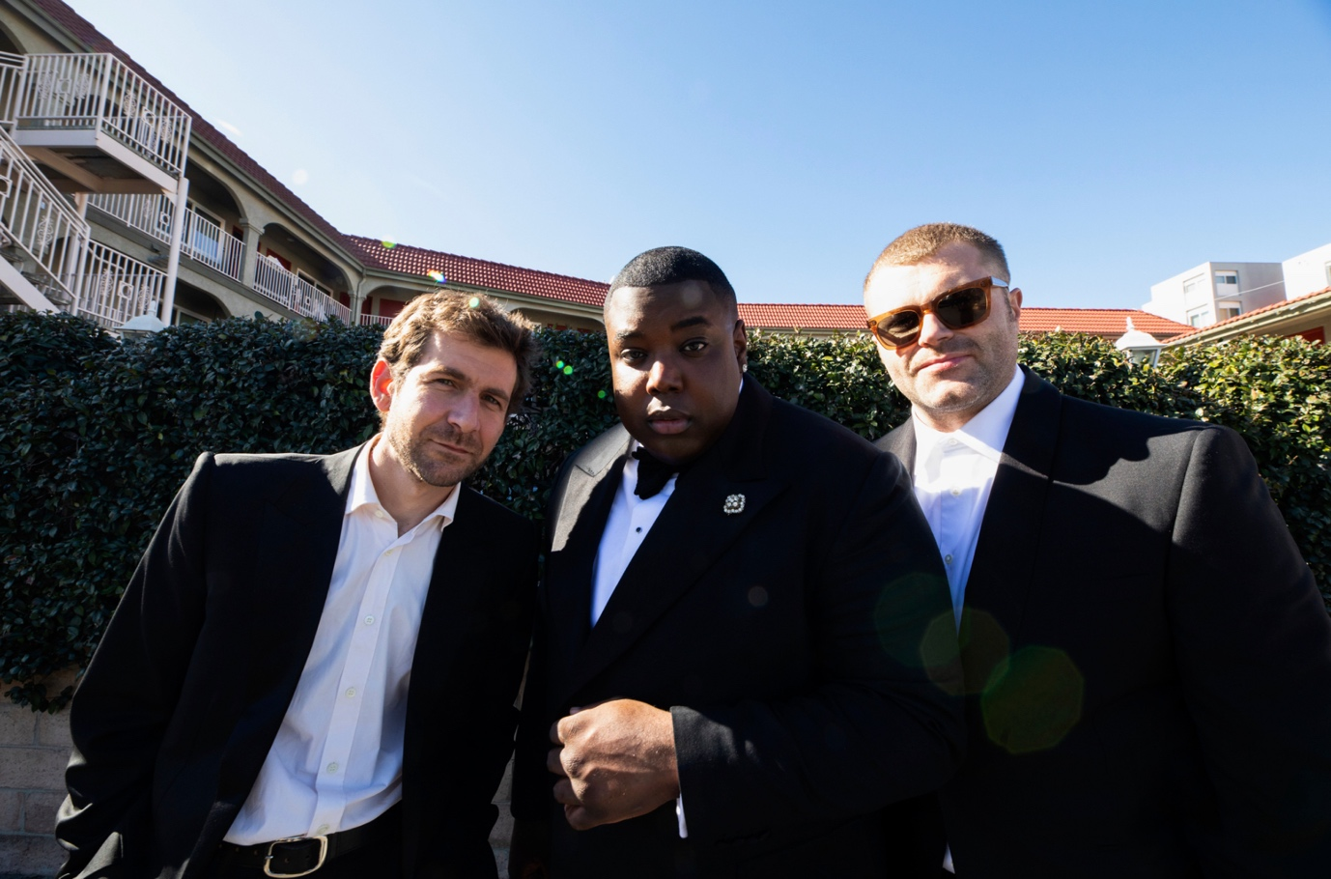
DOWNLOAD PRESS ASSETS HERE
Credit: Renee Parkhurst

“The core component of the emerging group is Jacob Lusk, the charismatic, fabulous-in-every-way singer who charmingly channels Solomon Burke and the heart of Motown soul in every side-step stage movement.” – VARIETY
“Soul salvation” – THE LOS ANGELES TIMES
“The L.A.-based trio fuse soul, R&B, and nu-gospel with breathtaking vocals and powerful lyrics, resulting in music that feels both timeless and new.” – ENTERTAINMENT WEEKLY
“Overflowing with heart, chilling vocals, and some expertly played violin, this release is nothing if not glorious, and it isn’t one to miss.” – VMAN
“…one of the greatest live acts in the world today” – ROLLING STONE UK

“With their glorious, soaring sound, Gabriels seem unstoppable” – THE GUARDIAN
JULY 7, 2023 – Gabriels are thrilled to share the release of their full debut album, Angels & Queens.
Listen to Angels & Queens HERE
The release follows the band’s stirring, show-stopping performance at Glastonbury last month, and vocalist Jacob Lusk’s special guest slot with Elton John to close the festival.
Angels & Queens is the culmination of 18 months non-stop touring, ingratiating themselves to every city they stop in and collecting memories and inspiration as they traveled. The British-American trio have brought their shared message of hope, love and positivity and radiated right across the globe.
The 13-track record is released via Elektra/Atlas Artists, fellow Compton native and GRAMMY-Award winning producer Sounwave (Kendrick Lamar, Beyoncé, Chloe x Halle).

Angels & Queens incorporates a new recording of the band’s seminal debut single, “Love & Hate In A Different Time,” and songs that have already become staples of the band’s live set including “Offering” and “Glory.” The legions of fans who have attended Gabriels’ live shows and festival appearances may also recognize the double punch medley of new track “Professional” which segues into “We Will Remember,” Gabriels’ longstanding reworking of the Barbara Streisand classic, “The Way We Were.”

Gabriels are Jacob Lusk, Ryan Hope, and Ari Balouzian.

GABRIELS | 2023 NORTH AMERICAN TOUR DATES:
7/27 – New York, NY @ Webster Hall
7/29 – Newport, RI @ Newport Folk Festival
8/4 – Montreal, QC @ Osheaga Festival
8/6 – Chicago, IL @ Lollapalooza
8/12 – Los Angeles, CA @ The Ford Theatre
8/13 – San Francisco, CA @ Outside Lands Festival

GABRIELS
Angels & Queens
AVAILABLE NOW
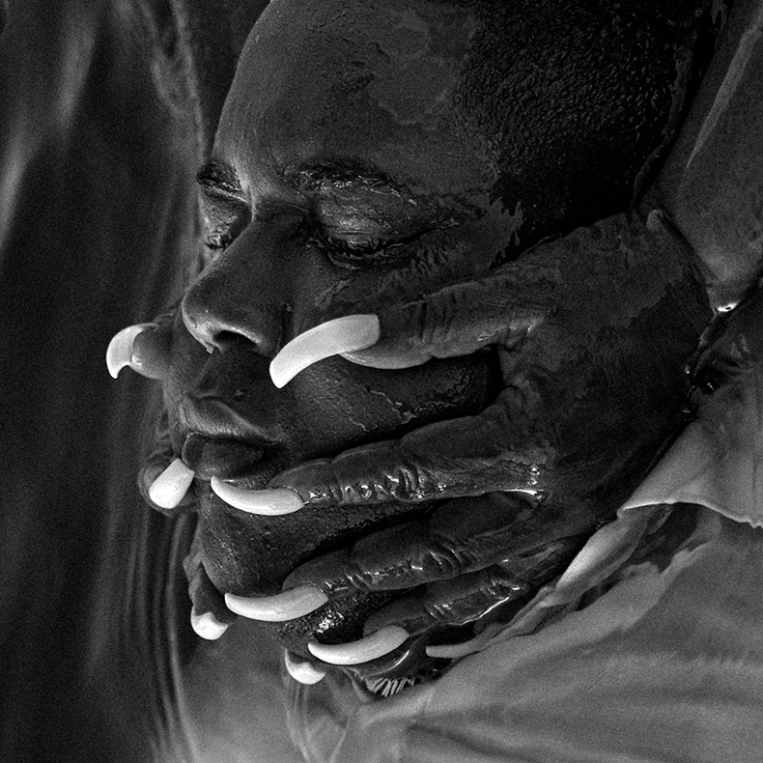

Tracklisting:
- Offering
- The Blind
- Angels & Queens
- Taboo
- To the Moon and Back
- Professional
- We Will Remember
- Remember Me
- If You Only Knew
- Love and Hate in a Different Time
- Glory
- Great Wind
- Mama

CONNECT WITH GABRIELS:
WEBSITE | INSTAGRAM | TWITTER | YOUTUBE | TIKTOK
# # #
For more information on Gabriels, please contact:
Sarah Goldstein & Sydney Worden
sarahgoldstein@elektra.com | sydneyworden@elektra.com

