FOR IMMEDIATE RELEASE
AUGUST 25, 2023

DBLBLK RECORDS/ELEKTRA’S RILEY THOMAS IS SIRIUSXM THE HIGHWAY'S NEWEST “HIGHWAY FIND”

ARENA-READY NEW SINGLE “I’LL BE DAMNED” DEBUTED ON THE HORIZON

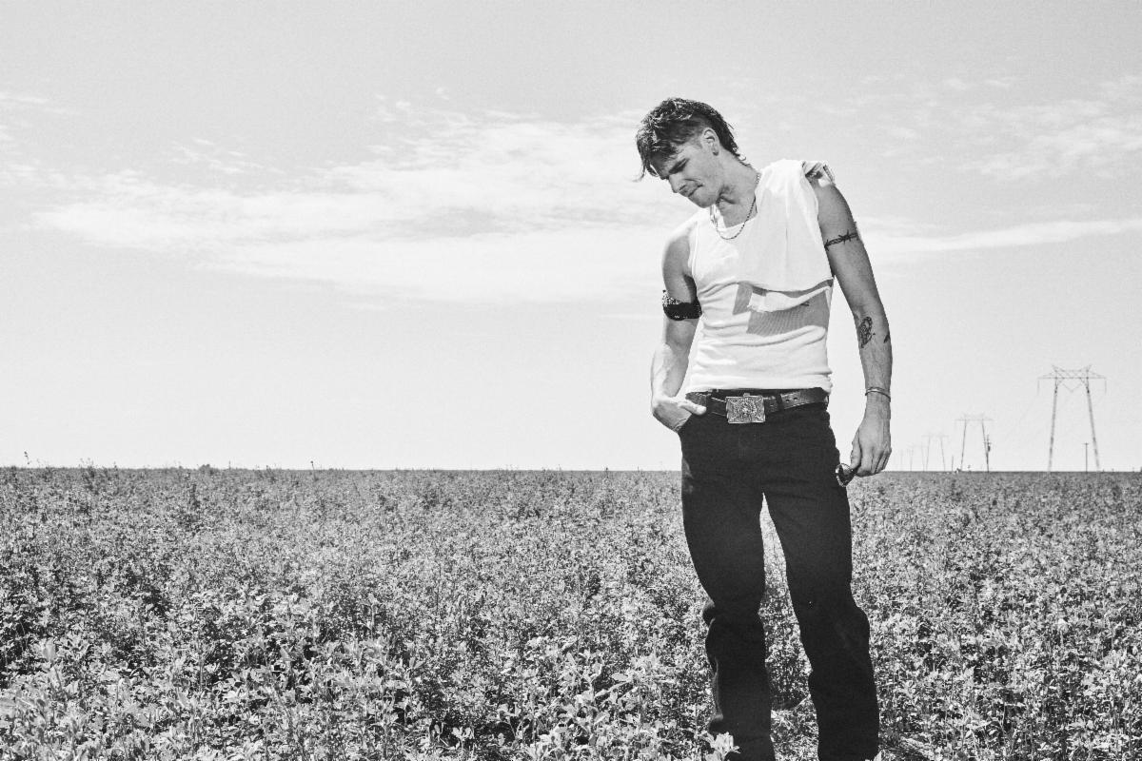

Photo credit: Jimmy Fontaine

NASHVILLE, TENN. – Following Billboard’s announcement of his signing to DBLBLK Records/Elektra, and the release of his major label debut single “I’ll Be Damned,” country and rock maverick Riley Thomas has added another impressive accolade to a whirlwind summer. Announced today at SiriusXM’s Music Row Happy Hour live from Margaritaville in downtown Nashville, the Florida-born, Nashville-based artist has been selected as SiriusXM The Highway's latest “Highway Find.”

A coveted honor within the country music community, the “Highway Find” program is part of SiriusXM The Highway’s (channel 56) commitment to spotlighting outstanding new talent in the genre. Riley Thomas joins an elite group of power players with the accolade, including 2022 ACM New Male Artist of the Year Parker McCollum, reigning CMA Entertainer of the Year Luke Combs, Griffen Palmer, Gabby Barrett, Maren Morris, Dan + Shay, Florida Georgia Line, and many more.

“Stepping out of the bar to hear ‘I’ll Be Damned’ on the radio for the first time was one of those moments you live for,” shares Riley Thomas. “I’m hugely grateful to Ania Hammar and the whole team at SiriuxXM The Highway for all of the love they have given to me and my music. Y’all keep listening, I’ll be damned.”

Riley initially emerged as a phenomenon on his own terms with his debut single “Cowboys Did Cocaine.” Released independently last year, the song has already amassed over 20 million streams and counting. Behind the scenes, he’s also notably co-written for the likes of Kelsey Karter & The Heroines, Jelly Roll, and more. “I’ll Be Damned” sets the stage for more new music to come later this year.

ABOUT RILEY THOMAS
As if breaking the speed limit down route 66 with the top down and the radio up, Riley Thomas traffics between recklessly raw country and unapologetic rock ‘n’ roll spiked with just the right amount of metallic unpredictability and a righteous sense of humor. Think of it like putting Waylon Jennings, System of a Down, and Led Zeppelin in a saloon blender on high, soaking it in whiskey, and lighting it on fire after the first swig. Born and raised in Plant City, Florida, he grew up on a strawberry farm as one of eight kids. He learned “everything you need to know in the passenger seat of a Peterbilt” on long haul rides with his old man Rodney. Dad served the country as a sniper and the community as a Deacon, while mom Theresa held down the fort at home. At 19-years-old, Riley picked up and moved to Nashville to be a songwriter. He grinded nonstop and eventually ended up in Los Angeles, paying his dues in countless songwriting sessions and slinging guitar. He co-wrote “Love Goes On” by Kelsey Karter & The Heroines and “Kill A Man” for Jelly Roll’s blockbuster Whitsitt Chapel—which bowed in the Top 3 of the Billboard 200. Riley spent his last dime on his own song, “Cowboys Did Cocaine.” It gained traction on DSPs, piling up over 20 million streams. He caught the attention of DBLBLK Records/Elektra and inked a deal in 2023. Now, he’s asserting himself as the maverick rock and country have been waiting for on a series of singles, beginning with “I’ll Be Damned.”

Media Contacts

For Riley Thomas
Collin Citron | 300 Elektra Entertainment
collin.citron@300elektra.com

SiriusXM
Carolina Dubon
carolina.dubon@siriusxm.com

Marley Gerber
Marley.gerber@siriusxm.com

