

**BAILEY ZIMMERMAN ANNOUNCES 2024 INTERNATIONAL HEADLINING DATES FOR *RELIGIOUSLY. THE TOUR.***

**Makes CMA Fest Debut to Capacity Crowd;**

**Receives *Billboard*’s Country Rookie of the Year Award**

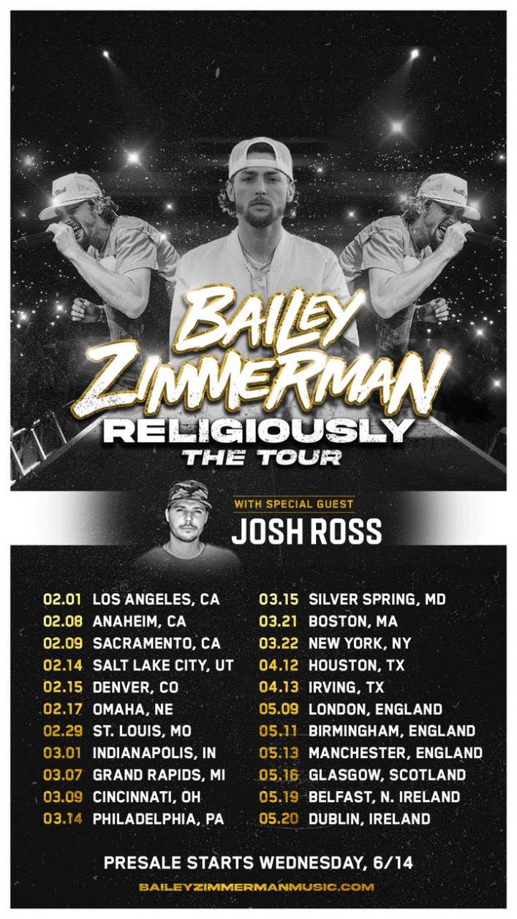

**NASHVILLE, Tenn. – (June 12, 2023) –** An unstoppable force in the country music genre, **Bailey Zimmerman** has just announced international headlining dates for **RELIGIOUSLY. THE TOUR.**, kicking off February 2024. Produced by Live Nation (except where noted below), the 20+ date tour begins on February 1 at Novo in Los Angeles, CA and will feature special guest Josh Ross. His biggest solo-touring run to date, the trek will make stops across the U.S. in major markets including St. Louis, MO; Philadelphia, PA; Boston, MA and more before heading overseas in May.

Tickets will be available starting Wednesday at 10am local time in each market through Bailey’s community presale. Sign up before Tuesday, June 13 at 11:59pm CST here: <https://baileyzimmerman.lnk.to/religiouslythetour-presale> or texting +1 (618) 228-3400 to get the presale code.

Working tirelessly to bring his music to fans around the world, the Illinois native is also out on the road now for **Morgan Wallen**'s 2023 ***One Night At A Time World Tour***. The 50+ date trek will visit multiple legendary venues including stadium stops at LA’s SoFi Stadium, Boston’s Fenway Park and Chicago’s Wrigley Field.

The news follows Zimmerman’s debut CMA Fest performance, closing the Riverfront Stage gates due to reaching a capacity-sized crowd. Earlier in the week, *Billboard* honored the breakout star with their inaugural **Country Rookie of the Year award**, including him as a featured speaker on their Future of Country Music panel as well.

His recently released debut, ***Religiously. The Album.*,** marked not only the **biggest streaming debut album of the year across all genres**, but also the **biggest streaming country debut of all time.** “Comfortably bruising and appealingly bruised” (***The New York Times***), the LP debuted **Top 3** on *Billboard*’s Top Country Albums chart, **No. 7** on their all-genre Billboard 200 chart and **No. 8** on The Billboard Canadian Album Chart.

Writing “some of mainstream country's most emotionally powerful tracks” (***The Tennessean***), Zimmerman has already surpassed **2 billion global streams** to date and recently celebrated a **six-week #1 single** with his **multi-Platinum** smash “**Rock And A Hard Place.**” Achieving this feat solidified his place in history as “the first male artist to spend six weeks atop Country Airplay just two or fewer promoted chart entries, in a lead role, into a career,” [according to *Billboard*](https://nam04.safelinks.protection.outlook.com/?url=https%253A%252F%252Fwww.billboard.com%252Fpro%252Fbailey-zimmerman-rock-and-a-hard-place-number-one-country-airplay-six-weeks%252F&data=05%257C01%257CMaryCatherine%2540wmg.com%257C22d705440a75470d737e08db5c6c5492%257C8367939002ec4ba1ad3d69da3fdd637e%257C0%257C0%257C638205392604130287%257CUnknown%257CTWFpbGZsb3d8eyJWIjoiMC4wLjAwMDAiLCJQIjoiV2luMzIiLCJBTiI6Ik1haWwiLCJXVCI6Mn0%253D%257C3000%257C%257C%257C&sdata=IXvzHO0GvhINo1IM6tpS4orCG7hVpPscBZq1xL963Es%253D&reserved=0).

Credited as “the biggest new country artist this side of Morgan Wallen” by***Rolling Stone***, the success of his record-shattering 2022 debut EP, ***Leave The Light On***, propelled the breakout superstar to close out 2022 as *Billboard*’s**No. 2 Top New Country Artist** and **No. 4 Top New Artist Overall**. In addition, he was the only country artist in 2022 to receive two Platinum certifications from the RIAA, beginning with his No. 1 debut single **“Fall In Love,”** the **fastest debut single to reach No. 1 at country radio since 2015** and **the first debut hit to make it all the way to No. 1 on the *Billboard* Country Airplay chart in 2022.**

**RELIGIOUSLY. THE TOUR. DATES:**

2/1/24 - Los Angeles, CA - Novo*

2/8/24 - Anaheim, CA - House of Blues

2/9/24 - Wheatland, CA - Hard Rock Live Sacramento

2/14/24 - Salt Lake City, UT - The Complex

2/15/24 - Denver, CO - Fillmore Auditorium

2/17/24 - Omaha, NE - The Steelhouse

2/29/24 - St. Louis, MO - The Pageant

3/1/24 - Indianapolis, IN - The Egyptian Room

3/7/24 - Grand Rapids, MI - GLC Live

3/9/24 - Cincinnati, OH - Brady Music Center

3/14/24 - Philadelphia, PA - Fillmore Philly

3/15/24 - Silver Springs, MD - The Filmore

3/21/24 - Boston, MA - MGM Music Hall at Fenway

3/22/24 - New York, NY - Hammerstein Ballroom

4/12/24 - Houston, TX - 713 Music Hall

4/13/24 - Irving, TX - Toyota Music Factory

5/9/24 - London, England - KOKO

5/11/24 - Birmingham, England - O2 Institute 2

5/13/24 - Manchester, England - Academy 2

5/16/24 - Glasgow, Scotland - The Garage

5/19/24 - Belfast, Northern Ireland - Limelight

5/20/24 - Dublin, Ireland - The Academy

*\*Not produced by Live Nation*

**About Live Nation Entertainment**

Live Nation Entertainment (NYSE: LYV) is the world’s leading live entertainment company comprised of global market leaders: Ticketmaster, Live Nation Concerts, and Live Nation Sponsorship. For additional information, visit [www.livenationentertainment.com](http://www.livenationentertainment.com).

**Contact info:**

Live Nation Concerts

Monique Sowinski | [moniquesowinski@livenation.com](mailto:moniquesowinski@livenation.com)

Navier Grimes | [naviergrimes@livenation.com](mailto:naviergrimes@livenation.com)

**ABOUT JOSH ROSS:**Echoing the primary themes of country infused with a fresh, modern sound, Josh Ross’s take on love, work, and play is often documented through his whirlwind experiences. Developing an ever-evolving career amidst the drawbacks of injuries, lockdowns, and conflicting relationships, Josh Ross is a country artist bound by the act of forging past and overcoming restraints. Josh Ross debuted with his independently released cathartic ballad on romantic losses, "First Taste Of Gone," which garnered stellar traction across North America for the Nashville-based singer. Capturing attention across the US with placement on Spotify's top country playlists like Hot Country, New Boots, and more, "First Taste of Gone" proved the rising Nashville star's emerging presence in the genre.

Recently, Josh Ross has pushed even further in his career with his major label signing to Universal Music Canada, teaming up with Universal Music Group Nashville, and management by The Core Entertainment. Often writing from personal experiences, Josh Ross has tallied more than 100 million streams across his collection of songs. In addition to “On A Different Night” and “First Taste of Gone,” his catalog includes summertime anthem “Tall Boys,” and the latest too-close-to-home emotional track “Red Flags.” This year, Josh Ross was announced as one of Spotify’s Hot Country Artists To Watch 2023 and already garnered his second Top 5 Canadian radio hit with “On A Different Night.” His debut US single, “Trouble,” is hitting country radio airwaves this summer, as he joins Nickelback and Brantley Gilbert on the GET ROLLIN’ TOUR. Stay tuned for more from Josh Ross as he continues to anchor himself as one of country’s most promising new artists.