TURNSTILE & BADBADNOTGOOD RELEASE NEW HEART DESIGNS

THREE-SONG EP FEATURES REIMAGINED VERSIONS
OF SONGS FROM TURNSTILE’S CELEBRATED LP GLOW ON

SHARE “NEW HEART DESIGNS” FULL EP VIDEO

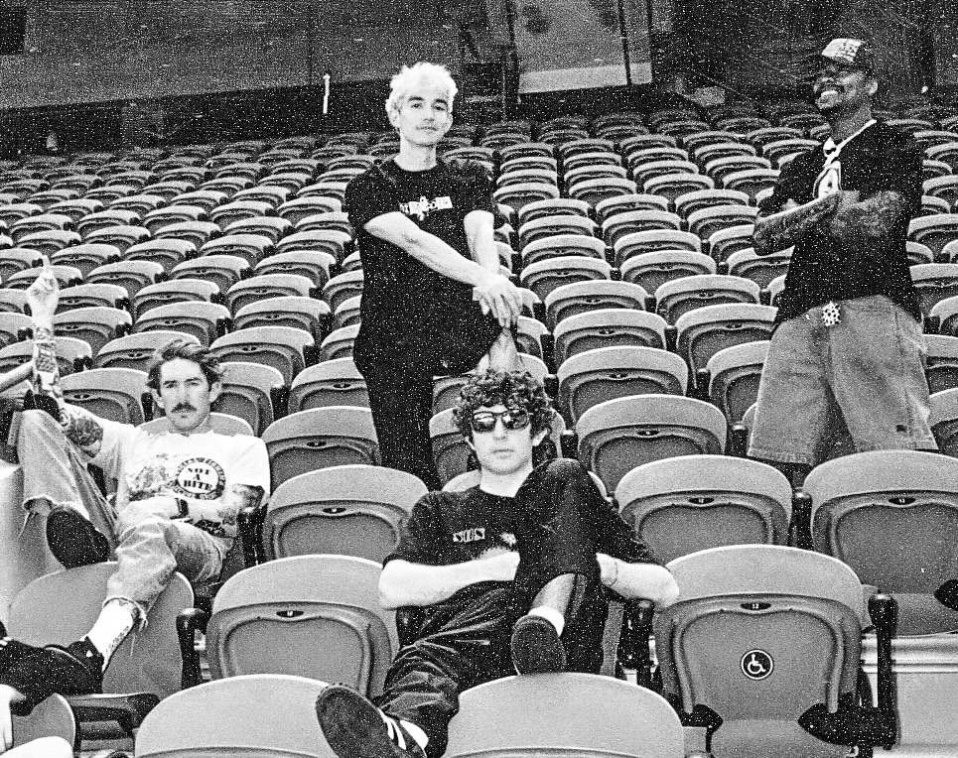
PHOTO CREDIT: ALEXIS GROSS

AUGUST 11, 2023 – Baltimore punk band TURNSTILE and Toronto alt-jazz ensemble BADBADNOTGOOD have released New Heart Designs, a collaborative three-song EP which sees the two groups teaming up to reimagine songs from TURNSTILE’s celebrated LP GLOW ON [EP artwork / tracklist below]. TURNSTILE have also shared “New Heart Designs,” a companion full EP video for the newly reworked versions of “Mystery,” “Alien Love Call” (Ft. Blood Orange), and “Underwater Boi,” which was filmed and edited by Alex Henery – Watch it HERE. New Heart Designs is available now on all streaming platforms with a vinyl release to follow later this year.

Recorded with producer Mike Elizondo and co-produced by TURNSTILE vocalist Brendan Yates, GLOW ON staked its claim as one of 2021’s top releases and earned the Baltimore band their first ever GRAMMY nominations at the 65th Annual GRAMMY Awards. The band received a total of three nods with “HOLIDAY” garnering nominations for both “Best Rock Song” and “Best Rock Performance,” while “BLACKOUT” scored a nomination in the “Best Metal Performance” category. Furthermore, GLOW ON earned year-end “Best of 2021” honors from: NPR, Rolling Stone, Pitchfork, Billboard, Stereogum, SPIN, Vulture, The FADER, The Ringer, The Washington Post, Los Angeles Times and more, with the band delivering performances on The Tonight Show starring Jimmy Fallon, Jimmy Kimmel Live!, Late Night with Seth Meyers, and NPR’s Tiny Desk (Home) Concert Series.

Selected as Stereogum’s Album Of The Week, Senior Editor Tom Breihan wrote “Before GLOW ON, TURNSTILE were already a truly special band, a ray of exploding energy. With this album, they’ve hit dizzy new heights…They’ve made a classic. I can’t even imagine what they’ll do next.” Pitchfork awarded the album ‘Best New Music’ attesting “The Baltimore band’s spectacular fourth record is all groove, riffs, and passion,” with The Recording Academy noting “The through line of all this is a lack of fear—of pushback, of resistance, of excommunication—that defines TURNSTILE.” NPR observed, “TURNSTILE has the ability to lure even the most poptimistic listener with spectacular hooks,” and Vulture hailed GLOW ON as “one of the best rock albums of the year.” Billboard affirmed “Ready or not, TURNSTILE is breaking through,” with FLOOD hailing the album as “An unforgettable magnum Opus.”

Comprised of Brendan Yates (Vocals), Franz Lyons (Bass/Vocals), Pat McCrory (Guitars), and Daniel Fang (Drums), TURNSTILE’s brand of youth-minded, youth-driven hardcore punk is intent on breaking down barriers, sonically and ideologically.

TURNSTILE & BADBADNOTGOOD
NEW HEART DESIGNS
- Mystery
- Alien Love Call (Ft. Blood Orange)
- Underwater Boi

TURNSTILE
2023 LIVE DATES

8/16 - STRETFORD, UNITED KINGDOM - O2 VICTORIA WAREHOUSE
8/17 - CHARLEVILLE-MÉZIÈRES, FRANCE - CABARET VERT 2023
8/19 - HASSELT, BELGIUM - PUKKELPOP FESTIVAL 2023
8/20 - BIDDINGHUIZEN, NETHERLANDS - LOWLANDS FESTIVAL 2023
8/22 - ZURICH, SWITZERLAND - X-TRA
8/23 - ROMANO D'EZZELINO, ITALY - AMA MUSIC FESTIVAL 2023
8/25 - SAINT-CLOUD, FRANCE - ROCK EN SEINE 2023
9/15 - CHICAGO, ILLINOIS - RIOT FEST 2023
9/23 - BIRMINGHAM, ALABAMA – FURNACE FEST 2023
9/24 - LOUISVILLE, KENTUCKY - LOUDER THAN LIFE 2023
10/7 - SACRAMENTO, CALIFORNIA - AFTERSHOCK 2023

Connect with TURNSTILE:
WEBSITE / INSTAGRAM / FACEBOOK / TWITTER / YOUTUBE / SPOTIFY / APPLE MUSIC

