SYDNEY ROSE SHARES NEW SINGLE AND VIDEO
“YOU’D BE STARS (FEAT. CHLOE MORIONDO)”
WATCH HERE

ANNOUNCES DEBUT ALBUM ONE SIDED
ARRIVING NOVEMBER 10 VIA PUBLIC CONSUMPTION
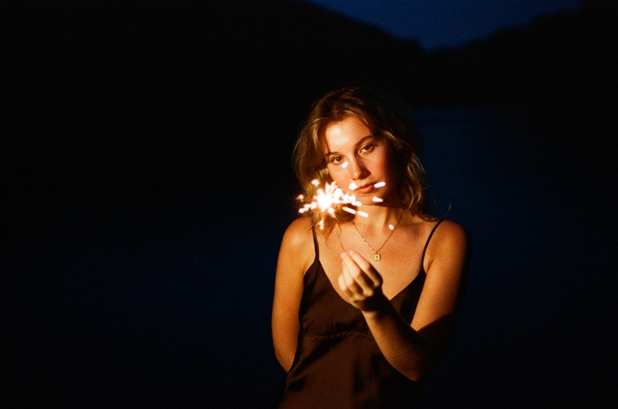
Download Press Assets HERE
SEPTEMBER 20, 2023 – 20-year-old singer/songwriter Sydney Rose has announced her debut album One Sided, set for release on November 10th. The news is heralded by the arrival of new single and video “You’d Be Stars (feat. chloe moriondo),” which premiered this morning via FLOOD Magazine who celebrated the track as "a breezy, late-summer exhalation."Written solely by Rose, “You’d Be Stars” lovingly explores the small, shared moments of friendship that create a lasting bond. The video, directed by Syd Ostrander, follows Rose and Moriondo as they spend a day together, enjoying the ease and effortlessness of each other’s company. The video is streaming now on Sydney’s official YouTube channel, and One Sided is available for presave now via Public Consumption.
Rose revealed of the track, “‘You’d Be Stars’ is definitely one of the happier songs I’ve written. It pays tribute to an important friendship and how happy I was at the time. The song incorporates all the things that made the relationship so special, like car rides, phone calls, and movies!”
She continued, “This track is probably the only happy song on One Sided. The album touches on friendship breakups, growing up and being afraid of change. I wanted this song to focus on the beautiful thing that is female friendship. It’s kind of like a breath of fresh air on the album; a reminder that even though I’ve lost a lot of friends, this kind of friendship still exists.”
In 2022, her debut EP You Never Met Me and its follow-up This Kind of Thing Doesn’t Last showcased intimate lyricism and a knack for candid honesty, with the help of understated synths, muted drum machines, and stacked harmonies. Now, with her debut album One Sided, Rose returns to her stripped-back acoustic roots, offering tenderhearted meditations on childhood, love, and the evolution of friendship, with a guitar in hand.
The album announcement follows a slew of 2023 singles, including an intimate cover of The Killers’ iconic track “Mr. Brightside.” Spring release “I can’t live without you (feat. Charlie Oriain),” was coined by Sweety High as “a whispery, gorgeous ballad straight from the heart,” while Stereogum praised “Tell Him I Miss Him” as “lovely and delicate,” noting, “[the] achingly spare song … slowly layers on more instruments and effects without losing any heart.”
Sydney shared her latest EP This Kind Of Thing Doesn’t Last in November, which arrived alongside a self-directed official music video for focus track “Too Fast.” Last summer, the artist shared her debut EP You Never Met Me, which included previously released singles “Phoebe Told Me,” “Things That Don’t Exist (feat. Zachary Knowles),” and “I’ll Never Get Over It” and arrived to critical acclaim, with PEOPLE Magazine naming her one of their Emerging Artists To Watch and Under The Radar attesting, “‘You Never Met Me’ is the sound of Rose finding herself in her music and introducing herself to the world, tracing all of the messy contours of teenage heartbreak in the process.” Amplify Her Voice also celebrated the effort, stating “Rose re-discovers different parts of herself on her own, presenting her real self through a delicately honest six-song collection.”
(Album Art + Tracklisting Below)

SYDNEY ROSE
One Sided – OUT NOVEMBER 10TH
PRESAVE NOW

- Filing Our Papers
- Unmade Bed
- I Think of How It Ends
- The New Kid
- You’d Be Stars (feat. chloe moriondo)
- Pretty Words
- The House I Grew Up In
- Growing
- Same Car
- Cool Girl
- What Kind Of Winner
- Out Of Service
- Throwing Rocks

CONNECT WITH Sydney Rose
TIKTOK
YOUTUBE
INSTAGRAM

CONTACT:
Sarah Goldstein
SarahGoldstein@elektra.com

