VICTORIA CANAL DEBUTS EP WELL WELL
OUT NOW VIA ELEKTRA

SHARES “BLACK SWAN” OFFICIAL LIVE SESSION
WATCH HERE

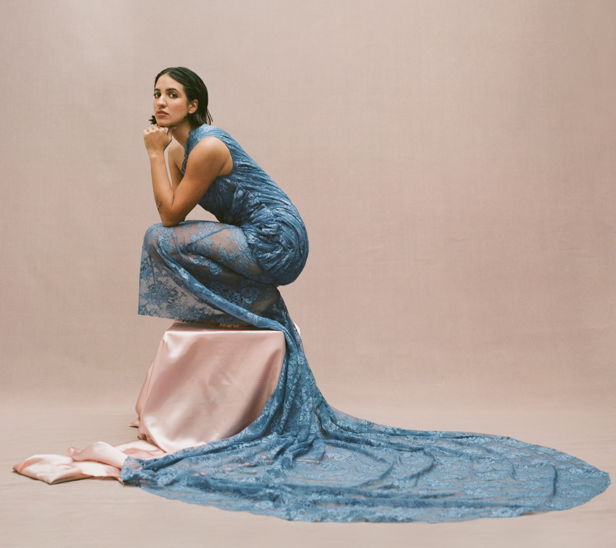
Hi-res assets here // photo credit: Karina Barberis

“perceptive, unflinching songs… as the world wakes up to her many talents.” – THE OBSERVER

“her gentle and ruminative form of songwriting is finally getting the recognition it deserves” - i-D

“WELL WELL represents her at her most vulnerable and her most brave” – THE GAY TIMES

“WELL WELL makes it clearer than ever that she is taking the music world by storm — in her own right, on her own terms.” – 1883 MAGAZINE

AUGUST 18, 2023 – Singer-songwriter and multi-instrumentalist Victoria Canal has shared new EP WELL WELL. The six-track collection is available now via Elektra and arrives alongside an official live session of “Black Swan,” which is streaming on Victoria’s official YouTube channel now.

After experiencing creative and emotional catharsis through the creation of her 2022 EP Elegy, WELL WELL finds Canal is turning the lens back on herself to look inwards: grown from heartache and made with unabashed honesty, these new songs find the artist at her most vulnerable—and her most courageous. Recent singles “Shape” and “She Walks In” were the first time she’d shared on the themes of body image and body dysmorphia, pertaining in part to her limb difference, while “Company” arrived as a warm, heartfelt ode to friendship, exploring the liminal space that exists between platonic and queer love.

WELL WELL embraces the discomfort of self-analysis: “These days I’m writing mostly to confront things about myself in order to gain more of an understanding and acceptance of them,” she shares. “The phrase ‘WELL WELL’ struck me as a natural follow up to ‘Elegy.’ I’ve grieved this person and now I’m dealing with what’s left,” Canal resolves, “I needed to stare myself in the face and realize that this is it. It’s a wounded rebirth.”

On standout single “Black Swan,” she adds: “‘WELL WELL’ was my study in the mirror for what was left after a total life shift. Who remains when the cushion of certainty is gone from underneath you? When you’re new to adulthood and trying to face your insecurities, your relationships, your sexuality, among other things? This project excavates those parts of myself in an attempt to assume my newfound adulthood.

‘Black Swan’ came to me in a period of crushing comparison, perfectionism, and pretty steep low self-esteem. I wanted to untangle the feeling of wanting so deeply to be different to who I am at the core. For my enneagram girlies, this song is a 4, through and through.”

Working with the likes of S. Carey (Bon Iver), Grammy winners Madison Cunningham and Tony Berg helped push the musician creatively in a way she’s never experienced before. “In past projects I’ve been on my own or working with my buddies, which is amazing,” she remarks, “But this time I got to work with some of my heroes while also holding my own in the studio.”

WELL WELL will be released on 12” black vinyl, with the full EP on side A, and her 2022 project Elegy on side B. It will be available via https://www.victoriacanal.com/ and from all good record retailers.

Victoria Canal recently won the Rising Star award at the prestigious Ivor Novellos, which celebrates the craft of songwriters, composers and creators, was the recipient of an Attitude Pride Icon Award and was also named BBC Radio 1’s Future Artist for June.

After weeks spent on the road this summer supporting Hozier, Victoria Canal will play a run of UK headline shows next month, before heading to the US for dates supporting Sammy Rae and Friends. Remaining tickets on sale now, see below for full list of dates.

About Victoria Canal:
25 year-old singer, songwriter, producer and activist Victoria Canal makes soul-stirring, emotive pop music. Born in Munich, Spanish-American Canal says her international upbringing fostered her love for a nomadic life in music. A proud “third culture kid,” she lived everywhere from Shanghai, Tokyo, Amsterdam, London, and Dubai to Atlanta, New York, and Forth Worth, and is proud of her identity as a queer, disabled, mixed-heritage woman, which fuels much of her activism.

Last year Canal released her EP Elegy, which delicately dealt with themes of grief and death, and featured the single ‘swan song’, which Chris Martin of Coldplay hailed as ‘one of the best songs ever written’. She performed “swan song” on the recent series of Later… with Jools Holland, appearing alongside the likes of Self Esteem and The 1975.

Canal also made her television acting debut in acclaimed Apple TV+ anthology series Little America, starring in the season’s moving episode “The Indoor Arm” as a Spanish-speaking Salvadorian refugee in the 80s who comes to America to live with her sister. She also wrote “Bring It On” the theme song for Apple TV+ series Best Foot Forward, based on the book by Paralympic skier Josh Sundquist.

VICTORIA CANAL 2023 TOUR DATES

September 5 - The Lower Third - London, UK – SOLD OUT
September 6 - Deaf Institute, The Lodge - Manchester, UK – SOLD OUT
September 7 - Sunflower Lounge - Birmingham, UK
September 8 - The Louisiana - Bristol, UK – SOLD OUT
September 9- Webster Theatre - Glasgow, UK
September 13 - Secret Show - Brussels, BE
September 16 - Privatclub - Berlin, DE
September 29 - Stone Family Field Trip - Liberty Lake, WA
October 14 - Showbox Sodo - Seattle, WA *
October 15 - Crystal Ballroom - Portland, OR *
October 17 - Warfield - San Francisco, CA*
October 18 - Novo - Los Angeles, CA*
October 19 - House of Blues - San Diego, CA*
October 21 - Marquee Theatre - Phoenix, AZ *
December 5 - Rock Lobster - Antwerp, BE
December 6 - Le Pop Up Du Label - Paris, FR
December 7 - Paradiso (Upstairs) - Amsterdam, NL – SOLD OUT
December 15 - Culture House Emotia - Erpe-Mere, BE

* with Sammy Rae and friends

VICTORIA CANAL
WELL WELL EP
AVAILABLE NOW

Tracklist:
- Shape
- She Walks In
- Braver (ft. Madison Cunningham)
- Yes Man (ft. S. Carey)
- Company
- Black Swan

CONNECT WITH VICTORIA CANAL
Instagram | Twitter | TikTok | Facebook | YouTube

For U.S. press inquiries please contact:
Sarah Goldstein / sarahgoldstein@elektra.com
Ross Anderson / rossanderson@elektra.com

