VICTORIA CANAL ANNOUNCES
DEBUT U.S. HEADLINE TOUR
DATES KICK OFF MARCH 20 IN BOSTON, MA

“BRAVER (FEAT. MADISON CUNNINGHAM)” LIVE VIDEO
STREAMING NOW

WELL WELL EP OUT NOW

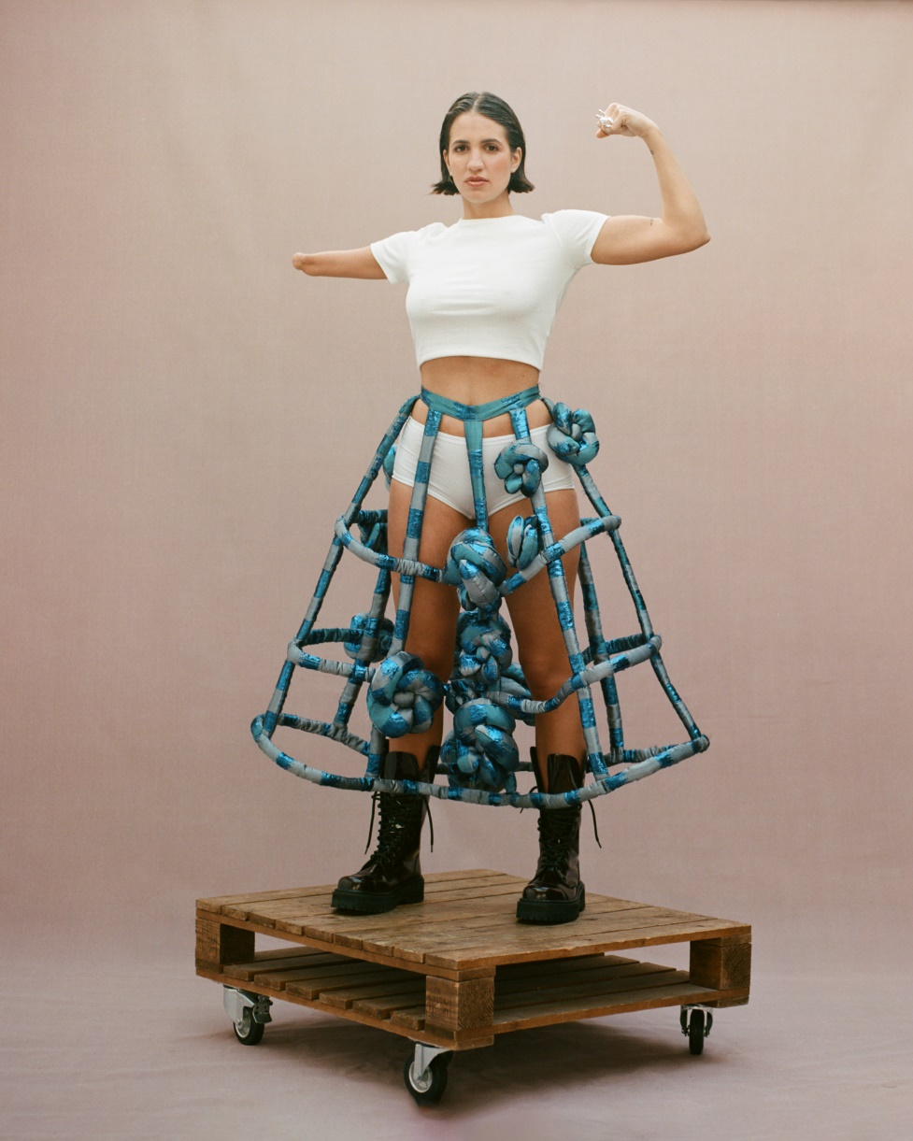
Hi-res assets here // photo credit: Karina Barberis

“Canal’s ascendant career is built on her ability to unflinchingly capture feelings… Her directness about body image and mental health has brought her an audience of people a lot like her.”
– THE NEW YORKER

“her gentle and ruminative form of songwriting is finally getting the recognition it deserves” – i-D

“a force to be reckoned with” – PEOPLE

"a tender blend of goosebump-inducing balladry akin to the kind of cataclysmic intensity of artists like Phoebe Bridgers or Holly Humberstone" – NME

“WELL WELL makes it clearer than ever that she is taking the music world by storm — in her own right, on her own terms.” – 1883 MAGAZINE

"the 25-year-old fearlessly explores the darkest nooks and crannies of the soul” – FLOOD MAGAZINE

“WELL WELL represents her at her most vulnerable and her most brave” – GAY TIMES
NOVEMBER 28, 2023 – Singer/songwriter and multi-instrumentalist Victoria Canal has announced her debut U.S. headline tour. The trek kicks off March 20 in Boston, MA and hits major markets including New York and Los Angeles before wrapping up in Seattle, WA on April 6 (tour itinerary below). Lucy Clearwater will provide support. Pre-sale tickets will be available beginning Wednesday, November 29 at 10am ET (presale code: WELLWELL), with general onsale beginning Friday, December 1 at 10am ET. For up-to-date ticketing information, please visit www.victoriacanal.com.

Earlier this month, Canal shared a live performance video for “Braver (feat. Madison Cunningham),” lifted from her recent EP WELL WELL. Both Victoria and Madison star together in the video which affectionately tells the story of the life of Canal’s mother, from growing up poor in the South to falling in love with someone halfway across the world. An ode to the sacrifices of the generations that have come before us, and the love for the ones we hold close, Canal sings: “You’re braver than I’ve ever been… what I’d give to have known you back then.”

Canal recently completed her debut headline tour of the UK, taking in shows across London, Manchester, Birmingham, Bristol and Glasgow, before heading on to play some headline European shows and a further run of support shows across the U.S. with Sammy Rae and friends.

A breakthrough year for Canal, she released her acclaimed EP WELL WELL, was profiled by The New Yorker, won the Rising Star award at the prestigious Ivor Novellos, which celebrates the craft of songwriters, composers and creators, was the recipient of an Attitude Pride Icon Award, was named one of PEOPLE’s “Emerging Artists To Watch,” supported Hozier across the UK and Europe, and was also named BBC Radio 1’s Future Artist for June.

After experiencing creative and emotional catharsis through the creation of her 2022 EP Elegy, WELL WELL finds Canal is turning the lens back on herself to look inwards: grown from heartache and made with unabashed honesty, these new songs find the artist at her most vulnerable—and her most courageous. Recent singles “Shape” and “She Walks In” were the first time she’d shared on the themes of body image and body dysmorphia, pertaining in part to her limb difference, while she describes “Company” as her “sweet gay love song.”

WELL WELL marks an expansion for Canal, not just thematically, but also with regard to collaborators. Working with the likes of S. Carey (Bon Iver), GRAMMY Award winners Madison Cunningham and Tony Berg helped push the musician creatively in a way she’s never experienced before. “In past projects I’ve been on my own or working with my buddies, which is amazing,” she remarks, “But this time I got to work with some of my heroes while also holding my own in the studio.” The artist attributes WELL WELL’s cohesive sound to her clear vision and the fact that everything was mixed at Sound City by veteran engineer Joseph Lorge (Blake Mills, Perfume Genius, Jon Batiste).

About Victoria Canal:
25 year-old singer, songwriter, producer and activist Victoria Canal makes soul-stirring, emotive pop music. Born in Munich, Spanish-American Canal says her international upbringing fostered her love for a nomadic life in music. A proud “third culture kid,” she lived everywhere from Shanghai, Tokyo, Amsterdam, London, and Dubai to Atlanta, New York, and Forth Worth, and is proud of her identity as a queer, disabled, mixed-heritage woman, which fuels much of her activism.

Last year, Canal released her EP Elegy, which delicately dealt with themes of grief and death, and featured the single “swan song,” which Chris Martin of Coldplay hailed as “one of the best songs ever written.” She performed “swan song” on the recent series of Later… with Jools Holland, appearing alongside the likes of Self Esteem and The 1975.

Canal also made her television acting debut in acclaimed Apple TV+ anthology series Little America, starring in the season’s moving episode The Indoor Arm as a Spanish-speaking Salvadorian refugee in the 80s who comes to America to live with her sister. She also wrote “Bring It On,” the theme song for Apple TV+ series Best Foot Forward, based on the book by Paralympic skier Josh Sundquist.

VICTORIA CANAL
2023-2024 TOUR DATES
All dates headlining except:
^ - with POMME
* - Festival appearance

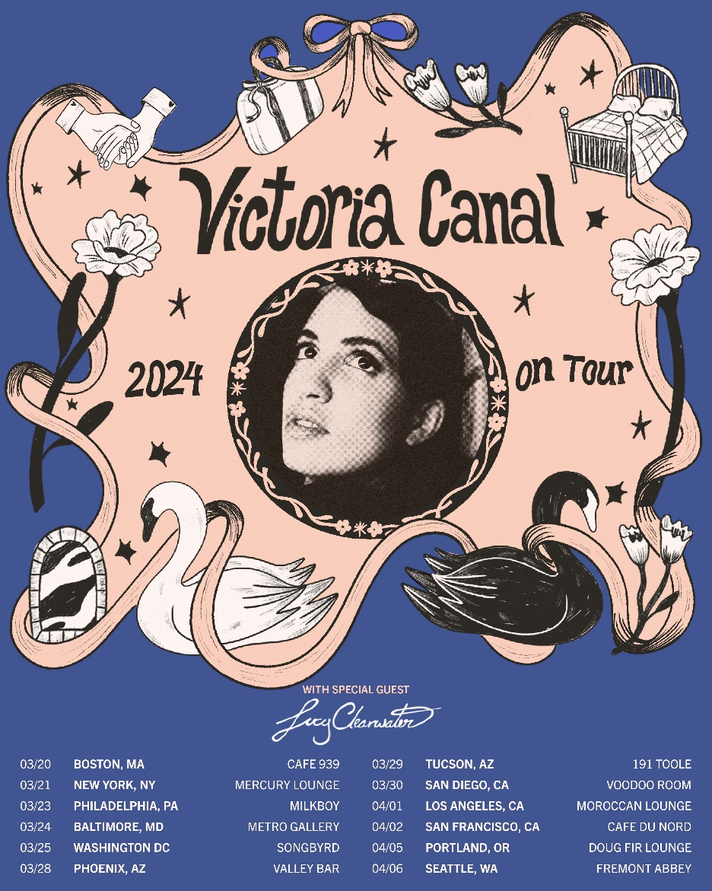

2023
November 29 Bordeaux, FR Théâtre Femina ^
November 30 Bordeaux FR La Rocher De Palmer ^

December 1 La Roche-sur-Yon, FR Quai M ^
December 5 Antwerp, BE Rock Lobster - SOLD OUT
December 6 Paris, FR Le Pop Up Du Label
December 7 Amsterdam, NL Paradiso (Upstairs) - SOLD OUT
December 15 Erpe-Mere, BE Culture House Emotia

2024
March 20 Boston, MA Cafe 939
March 21 New York, NY Mercury Lounge
March 23 Philadelphia, PA Milkboy
March 24 Baltimore, MD Metro Gallery
March 25 Washington DC Songbyrd
March 28 Phoenix, AZ Valley Bar
March 29 Tucson, AZ 191 Toole
March 30 San Diego, CA Voodoo Room @ The House of Blues
April 1 Los Angeles, CA Moroccan Lounge
April 2 San Francisco, CA Cafe DuNord
April 5 Portland, OR Doug Fir Lounge
April 6 Seattle, WA Fremont Abbey

May 16 Brighton, UK The Great Escape *

VICTORIA CANAL
WELL WELL EP
AVAILABLE NOW
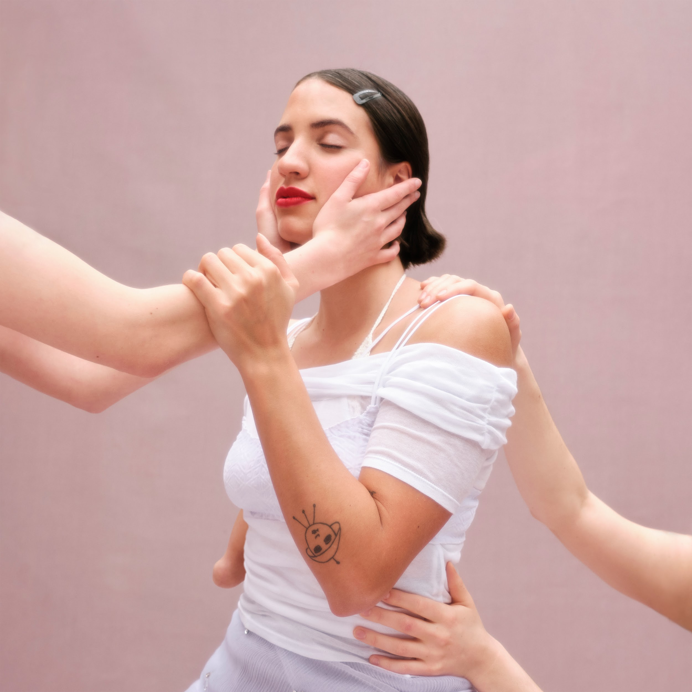

Tracklist:
- Shape
- She Walks In
- Braver (ft. Madison Cunningham)
- Yes Man (ft. S. Carey)
- Company
- Black Swan

CONNECT WITH VICTORIA CANAL
Instagram | Twitter | TikTok | Facebook | YouTube

For U.S. press inquiries please contact:
Sarah Goldstein / sarahgoldstein@elektra.com

