ALEC BENJAMIN RELEASES NEW SINGLE
“I SENT MY THERAPIST TO THERAPY”

WATCH THE MUSIC VIDEO HERE

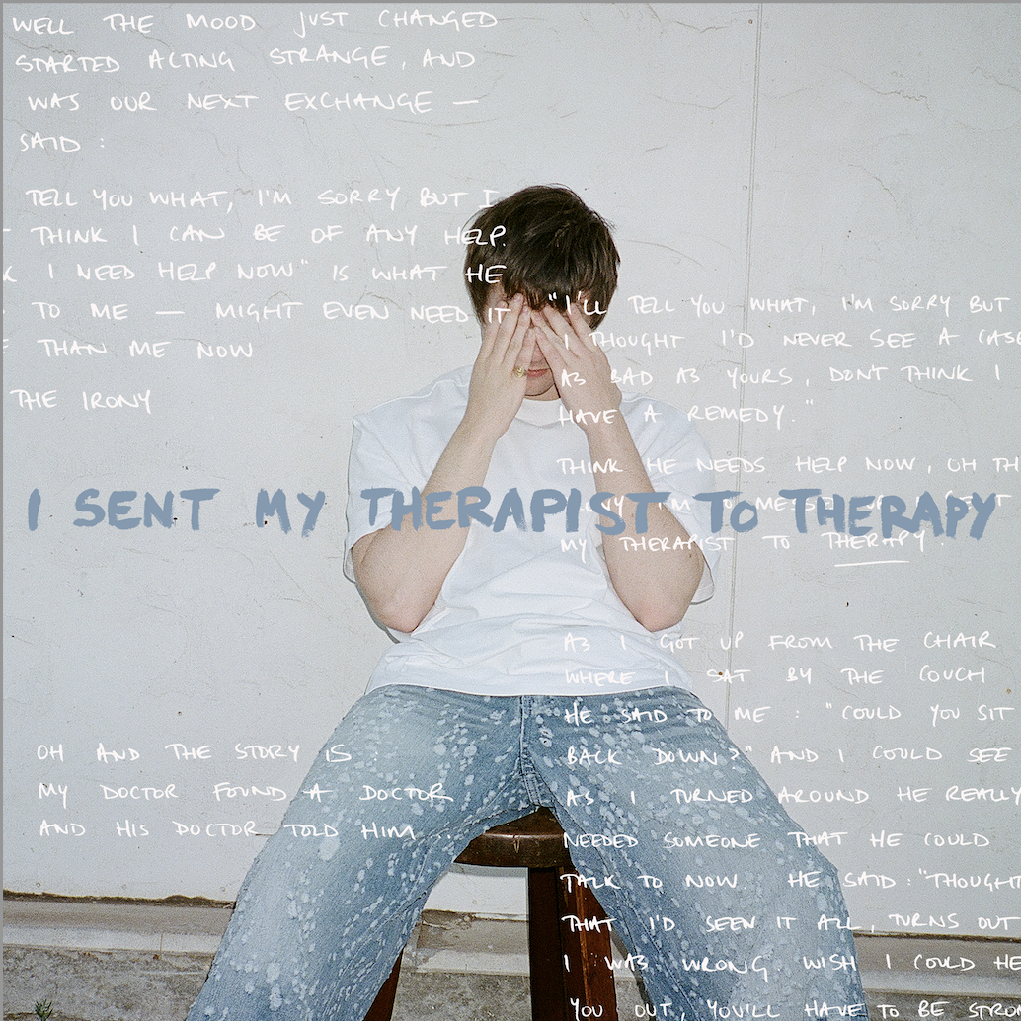

DECEMBER 8, 2023 – Multi-platinum singer-songwriter Alec Benjamin shares his infectious new single “I Sent My Therapist To Therapy,” out today on Elektra Entertainment. This marks the second glimpse into his forthcoming album, scheduled for release next year. Accompanying the release is a stunning video, which exclusively premiered today with Rolling Stone.

Penned by Benjamin himself alongside Jordi Peleg and Itay Shimoni, "I Sent My Therapist To Therapy" is a masterful blend of clever wordplay, seamlessly blending Benjamin’s signature storytelling with his mesmerizing vocals for a lively arrangement. Listen to the track HERE.

Directed by Matthew Trainor, video's creative direction complements Benjamin's whimsical lyrics, "I’m so messed up I sent my therapist to therapy," delivering a dramatic and unworldly visual. Watch the video HERE.

Reflecting on the track, Benjamin shares, “Releasing this song is the ultimate form of therapy. It combines the two most therapeutic things in my life into one; music and therapy itself. I hope listening to this song provides the same level of catharsis for anyone struggling with their mental health as writing it did for me.”

Building anticipation for the release, Benjamin teased fans across social media platforms in the weeks leading up to the launch. Engaging clips and subtle hints were shared, including a teaser during his debut performance of the album's first single, “Different Kind Of Beautiful” on Jimmy Kimmel Live! Upon release, “Different Kind Of Beautiful” was highlighted by UPROXX as "a love song in the purest form," and featured in Billboard’s Cool New Pop Songs. The track has garnered over 4 million streams to date.

Benjamin continues his emergence as a standout artist. Since his debut in 2018, Benjamin has been celebrated by both fans and critics for his exceptional narration. With the release of his sophomore album (Un)Commentary in 2022 Benjamin took to the road to connect with fans captivating audiences across the United States, Asia, Australia, and Europe as well as a debut performance at Coachella Valley Arts and Music Festival. Alec’s impressive resume includes 8B+ global streams, 12.5M+ social media followers across his platforms, 123M+ in playlist reach, and 1.6B+ YouTube views on his channel. An illustration of the connection Alec has forged with audiences worldwide.
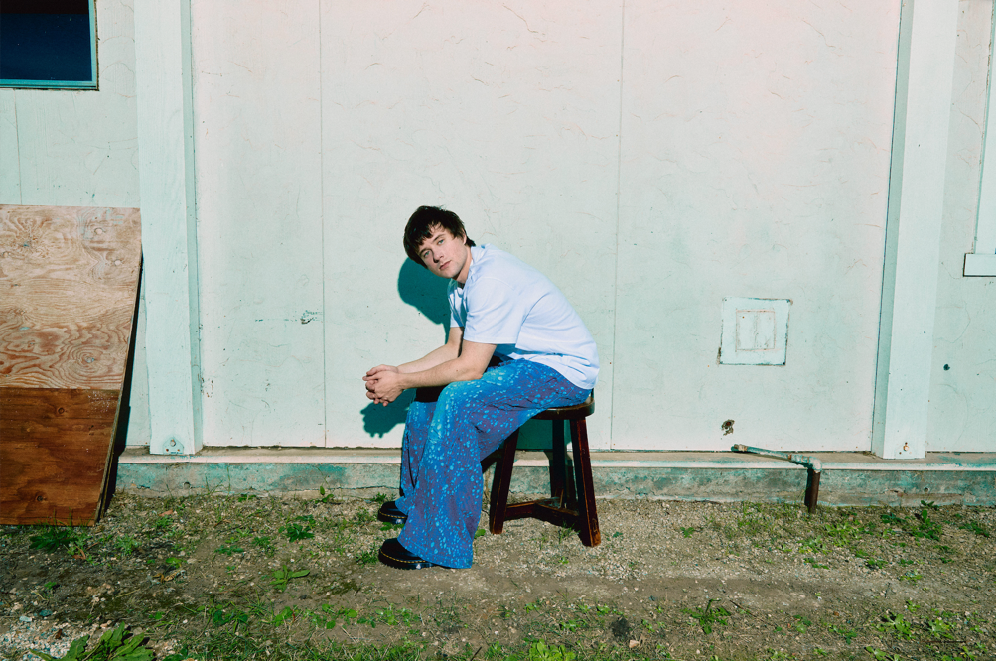
Photo Credit: Louis Browne
Download high-res art HERE.

CONNECT:
Website | Facebook | Twitter | Instagram | YouTube

For media inquiries, please contact:

﻿BT PR
Benny Tarantini | Benny@BTPR.biz
Moya Crowley | Moya@BTPR.biz

Elektra Entertainment
Glenn Fukushima | GlennFukushima@elektra.com
Collin Citron | CollinCitron@elektra.com

