FOR IMMEDIATE RELEASE
DECEMBER 6, 2023

THXSOMCH RETURNS WITH NEW SINGLE AND VIDEO
“WHEN THE DEVIL SPEAKS…”
LISTEN HERE | WATCH HERE

ANNOUNCES 2024 NORTH AMERICAN TOUR
TICKETS AVAILABLE THIS FRIDAY AT 10:00AM LOCAL TIME HERE

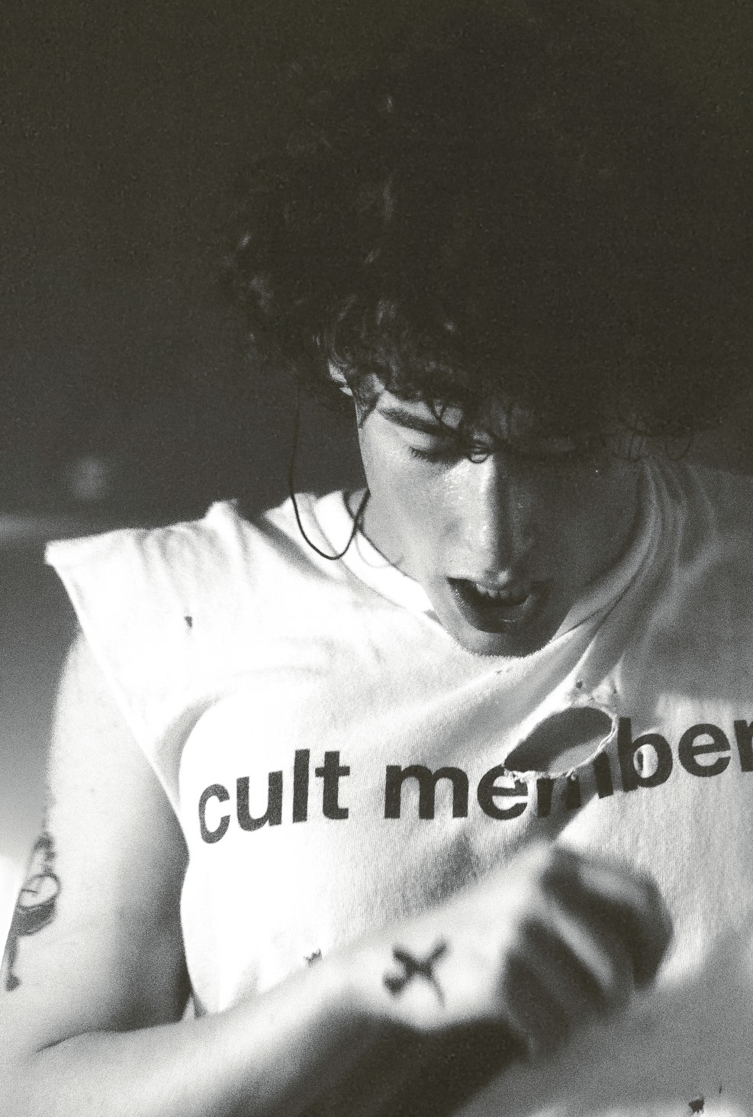
Photo credit: Hellen Elizondo

“ThxSoMch’s genre may be hard to pin down, but whatever you want to call it, it’s clearly working” — Complex
“Debatably the hottest independent up-and-comer in music right now” — Early Rising
“ThxSoMch is going to be a household name in the near future” — Sheesh
“One of the newcomers leading the charge in 2023” – Lyrical Lemonade

Rising Toronto-based artist ThxSoMch has returned with his brand new single “When The Devil Speaks…”. The song is available to stream and download beginning today HERE via Elektra. Watch the track’s video on ThxSoMch’s YouTube channel HERE.

“I could feel how high energy this song was going to be from the first voice recording demos on my phone,” shares ThxSoMch. "I previewed it to fans online, and I think they really connected with that energy. I didn’t know if I wanted to put it out until I saw that fans were blowing up my Discord asking for me to release it. This song is for them."

Produced by LMG and Dutch Reyz, “When The Devil Speaks…” represents yet another creative leap for ThxSoMch. Bright sonics belie the intensity of his introspective lyrics as he confesses, “When the devil speaks, he says to me, ‘Oh man, I think there’s something wrong inside of your head’.” As the pace picks up, he tops off the song with a manic plea, “I don’t need no counsel bitch, I need your fucking prayers.” Longtime collaborator Tommy Kiljoy directed the song’s video. The clip threads together live footage captured from his first-ever international trek, Sleez World Tour. The visual moves at the speed of the song, intercutting energetic moments from sold out shows in Europe, the UK, and the US. Watch it HERE.

This evening, ThxSoMch will deliver his very first hometown performance at Toronto’s Bovine Sex Club. Fans around the world can tune in to watch an innovative 360-degree livestream of the sold-out show exclusively via ThxSoMch’s Discord and YouTube. In 2024, ThxSoMch will launch a full-scale North American headline tour. It kicks off on April 6 at New York City’s Mercury Lounge, visits major markets coast-to-coast, and concludes on May 2 with a hometown show at Toronto’s Axis Club. Tickets for the tour go on sale this Friday, December 8 at 10:00am local time HERE. Check out the full itinerary below.

“When The Devil Speaks…” follows the November release of ThxSoMch’s single “LOST!”. Collaborating with multi-platinum, chart-topping producer BNYX [Travis Scott, Lil Uzi Vert, Drake, Yeat], “LOST!” sees ThxSoMch inject Nu metal influences into his ever-evolving sound. The track arrived to widespread critical praise. He’s the rare artist to earn acclaim from both Complex (“A magnetic mix of fury and high-octane energy”) and Revolver (“Evokes the break-stuff squall of Limp Bizkit and Korn”).

“LOST!” marked the first new music from ThxSoMch since the summer release of his singles “Waste My Mind” and “Spiral”. The tracks maintained the momentum of ThxSoMch’s critically acclaimed debut EP Sleez, which was released in May via Elektra. The EP arrived to widespread praise from Complex, Lyrical Lemonade, Sheesh, Early Rising, Our Generation Music, and more, and debuted in the Top 15 on Billboard’s Heatseekers Albums chart. Upon release, Ones To Watch proclaimed, “ThxSoMch has created a record full of unyielding energy, gut-wrenching lyrics, and powerful hooks that hit listeners hard.” Sleez is available to stream and download now HERE.

Offering a rare glimpse into his creative process, ThxSoMch spoke to Genius as part of the platform’s coveted Verified series to discuss Sleez’s breakout hit single “SPIT IN MY FACE!”. Watch the interview HERE. The propulsive track has already amassed over 375 million streams, charted on the Billboard Hot 100, and appeared on countless marquee playlists across streaming platforms.

ThxSoMch Tour Dates
December 06, 2023 - Toronto, ON - Bovine Sex Club - SOLD OUT
April 06, 2024 - New York, NY - Mercury Lounge
April 07, 2024 - Cambridge, MA - Middle East
April 09, 2024 - Philadelphia, PA - Kung Fu Neck Tie
April 11, 2024 - Atlanta, GA - The Masquerade (Purgatory)
April 12, 2024 - Nashville, TN - The End
April 14, 2024 - Columbus, OH - A&R Bar
April 16, 2024 - Chicago, IL - Cobra Lounge
April 17, 2024 - Minneapolis, MN - 7th Street Entry
April 19, 2024 - Denver, CO - Moes
April 24, 2024 - Seattle, WA - Madame Lou’s
April 26, 2024 - Portland, OR - Holocene
April 27, 2024 - San Francisco, CA - Brick + Mortar
April 30, 2024 - West Hollywood, CA - Troubadour
May 02, 2024 - Toronto, ON - Axis Club

THXSOMCH - “WHEN THE DEVIL SPEAKS…”
LISTEN HERE | WATCH THE VIDEO HERE

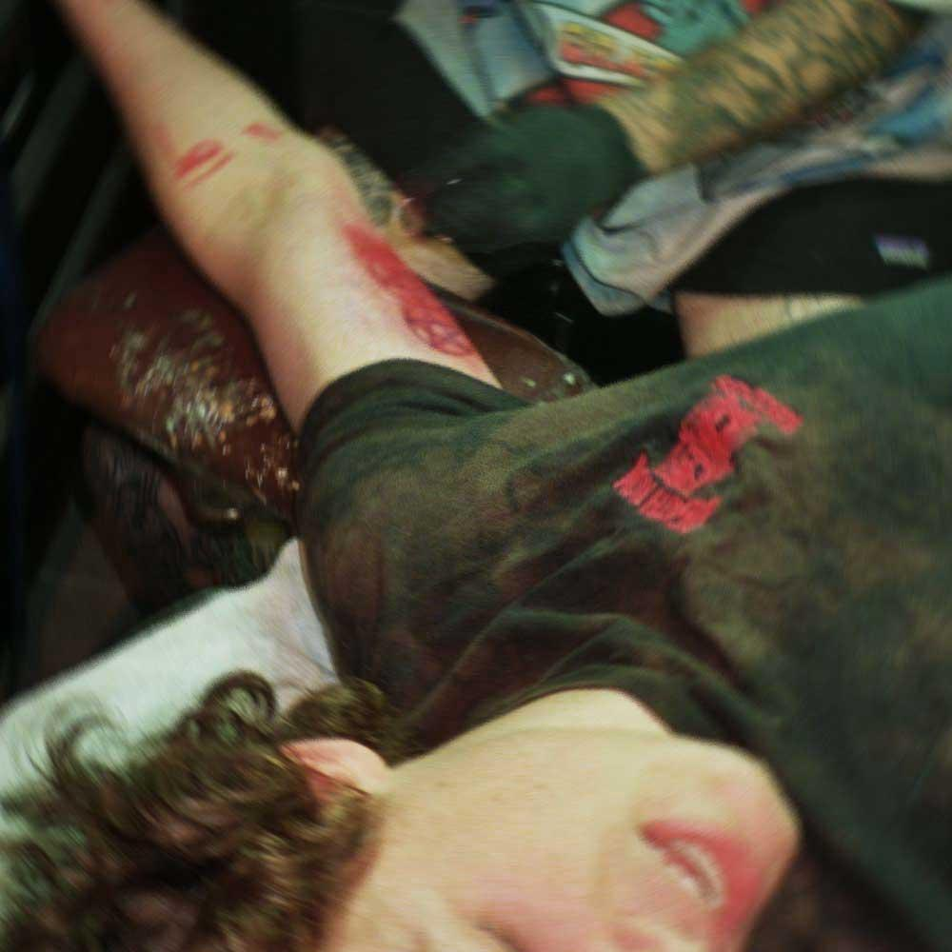

Instagram | Twitter | YouTube | Discord | TikTok

ThxSoMch Press Contact:
Collin Citron / Collin.Citron@300elektra.com

