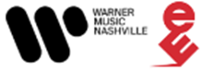

BAILEY ZIMMERMAN LAUNCHES INTO 2024 PROPELLED BY A MASSIVE 2023

Sold-Out Headlining Run - Religiously. The Tour. - Kicks Off in LA on 2.1

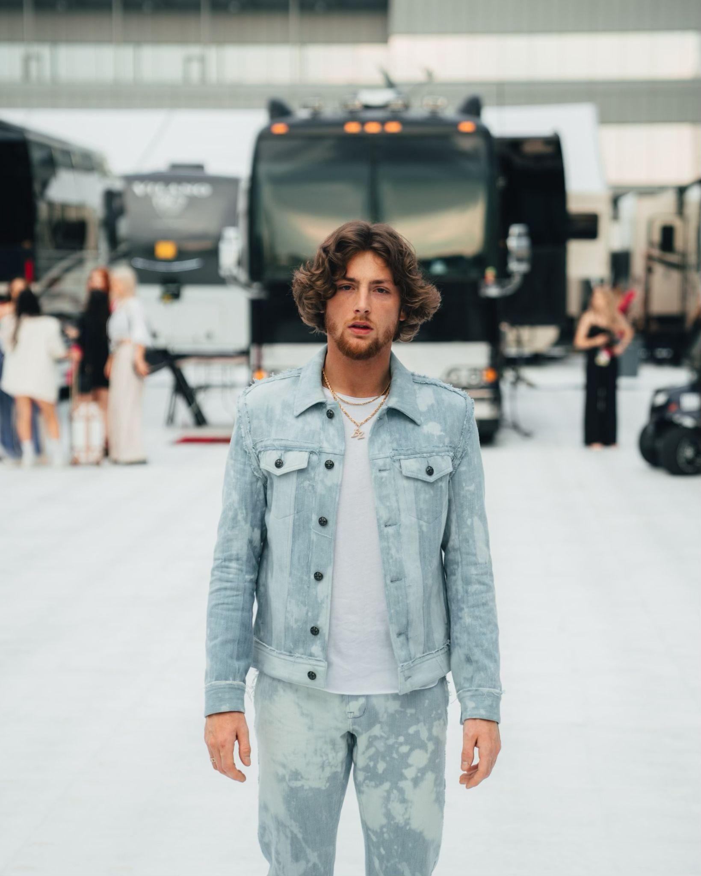

NASHVILLE, Tenn. – (January 10, 2024) – Bailey Zimmerman is ringing in the New Year strong, backed by a 2023 filled to the brim with more history-making accomplishments and outstanding career milestones. He brought the year to a close as part of a star-studded lineup for New Year’s Eve Live: Nashville’s Big Bash, the highest-rated country music program of the year. The rising star shared standout performances of his 2x Platinum and third-consecutive #1 “Religiously” and his 5x Platinum, six-week #1 “Rock And A Hard Place,” which holds the title of #1 Most Played Song on Country Radio in 2023.

Zimmerman is also climbing country radio charts now with his current single “Where It Ends,” while his Jonas Brothers collaboration “Strong Enough” nears Top 20 at pop radio. The celebrated singer/songwriter also saw three songs rank within the Top 20 most on-demand streamed country songs for 2023 (“Rock and A Hard Place” #7, “Religiously” #13, “Fall In Love” #19). Chosen as a Variety Hitmaker and Young Hollywood Impact Artist, the Billboard Country Rookie of the Year also became a first-time nominee at the Billboard Music Awards, ACM Awards, People's Choice Country Awards and CMT Music Awards in 2023.

Named one of New York Times Best Albums of 2023, his acclaimed debut, Religiously. The Album., arrived in May as the biggest streaming debut album of the year across all genres as well as the biggest streaming country debut of all time. It landed Top 3 on the Top Country Albums chart and No. 7 on the all-genre Billboard 200.

Lauded for his “relentless vulnerability and burning passion” (GRAMMY.com), the young superstar has already surpassed 3.5 billion global streams to date. He’ll kick off his completely sold-out Religiously. The Tour. on February 1 in LA while continuing to bring his stadium-ready country rock to select dates on Morgan Wallen’s massive One Night At A Time World Tour through 2024.

BAILEY ZIMMERMAN 2024 TOUR DATES
*Morgan Wallen’s One Night At A Time World Tour

Thu, February 01 - Los Angeles, CA - Novo
Thu, February 08 - Anaheim, CA - House of Blues
Fri, February 09 - Wheatland, CA - Hard Rock Live Sacramento
Wed, February 14 - Salt Lake City, UT - The Complex
Thu, February 15 - Denver, CO - Fillmore Auditorium
Sat, February 17 - Omaha, NE - The Steelhouse
Thu, February 29 - St. Louis, MO - The Pageant
Fri, March 01 - Indianapolis, IN - The Egyptian Room
Sat, March 02 - Indianapolis, IN - The Egyptian Room
Thu, March 07 - Grand Rapids, MI - GLC Live
Fri, March 08 - Grand Rapids, MI - GLC Live
Sat, March 09 - Cincinnati, OH - Brady Music Center
Thu, March 14 - Philadelphia, PA - Fillmore Philly
Fri, March 15 - Silver Springs, MD - The Filmore
Sat, March 16 - Silver Springs, MD - The Filmore
Thu, March 21 - Boston, MA - MGM Music Hall at Fenway
Fri, March 22 - New York, NY - Hammerstein Ballroom
Sat, March 23 - New York, NY - Hammerstein Ballroom
Thurs, April 04 - Indianapolis, IN - Lucas Oil Stadium*
Fri, April 05 - Lucas Oil Stadium - Indianapolis, IN (MW)
Fri, April 12 - Houston, TX - 713 Music Hall
Sat, April 13 - Irving, TX - Toyota Music Factory
Sat, April 20 - Oxford, MS - Vaught - Hemingway Stadium*
Thurs, May 02 - Nashville, TN - Nissan Stadium*
Thu, May 09 - London, England - KOKO
Sat, May 11 - Birmingham, England - O2 Institute 2
Mon, May 13 - Manchester, England - Academy 2
Thu, May 16 - Glasgow, Scotland - The Garage
Sun, May 19 - Belfast, Northern Ireland - Limelight
Mon, May 20 - Dublin, Ireland - The Academy
Sat, June 08 - Vibrant Music Hall - Waukee, IA
Thurs, June 20 - Minneapolis, MN - U.S. Bank Stadium*
Fri, June 21 - US Bank Stadium - Minneapolis, MN (MW)
Fri, June 28 - Red Hat Pavilion - Raleigh, NC
Fri, July 05 - White Water Amphitheater - New Braunfels, TX
Sat, July 06 - White Water Amphitheater - New Braunfels, TX
Thurs, July 18 - Charlotte, NC - Bank of America Stadium*
Fri, July 19 - Bank of America Stadium - Charlotte, NC (MW)
Fri, August 02 - Arrowhead Stadium - Kansas City, MO (MW)
Fri, August 16 - Live Oak Bank Pavilion - Wilmington, NC
Fri, August 30 - Choctow Casino - Durant, OK
Sat, August 31 - Choctow Casino - Durant, OK

