PRATEEK KUHAD DEBUTS NEW SINGLE “NO COMPLAINTS”
LISTEN HERE

ANNOUNCES THE “SILHOUETTES TOUR”
NORTH AMERICAN HEADLINE TOUR DATES
KICK OFF APRIL 25 IN ATLANTA, GA

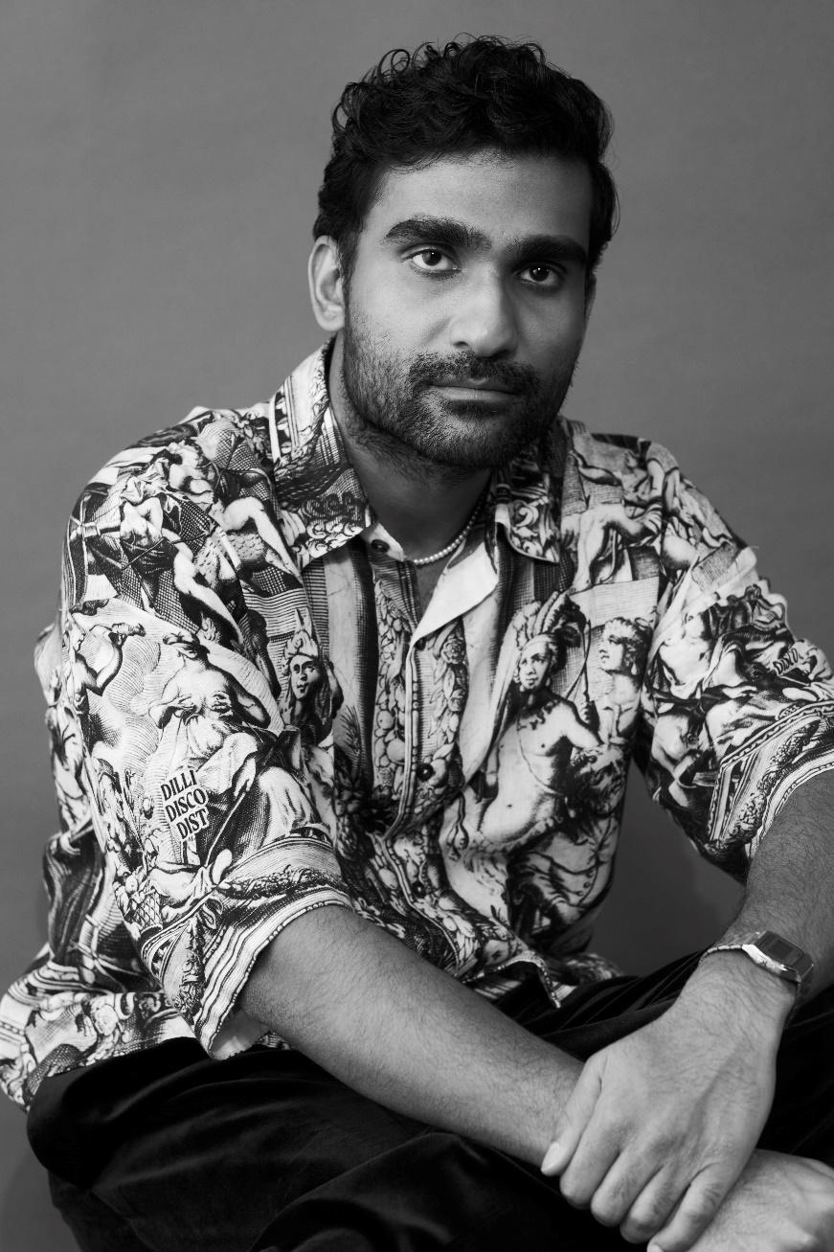
JANUARY 24, 2023 – Critically acclaimed singer-songwriter Prateek Kuhad has debuted new single “No Complaints.” Led by Kuhad's tender melody and tranquil guitar strums, the lilting, intimate ballad is available now on all streaming platforms via Elektra.
Alongside the new single, Kuhad has also announced the “Silhouettes Tour,” a headlining run that kicks off its North American leg on April 25 in Atlanta, GA and wraps up at the iconic Beacon Theatre in New York City on June 1 before dates in the UK and Europe this fall (tour itinerary below). Presale begins today at 10am local time, with general onsale beginning Friday, January 26 at 10am local time. For up to date ticketing information, please visit www.prateekkuhad.com.
In the fall, Kuhad shared the Mulaqat EP, a five-track collection sung entirely in Hindi. Lead single “Mulaqat” arrived alongside an official music video starring famed Indian actress Tara Sutaria. The video is streaming now on Kuhad’s official YouTube channel and has racked up nearly six million views since its release. The Mulaqat EP is available now via Elektra.
Last spring, Kuhad shared a deluxe version of his latest album The Way That Lovers Do, which included an alternate version of “Bloom” featuring guest vocals from Indian-American R&B standout Raveena. The deluxe arrived on the heels of a breakout stretch for Kuhad that's seen him grace the cover of India's Rolling Stone, earn praise from Barack Obama on his famous year-end lists and play to bigger audiences than ever across continents.
Despite all these accolades, Kuhad's road to global acclaim was never an inevitable one - first giving songwriting a try while an international student at NYU after finding his love of artists like Elliott Smith, Laura Marling and Fleet Foxes. Discovering a natural gift for the craft after dusting off his acoustic (he was kicked out of lessons during an earlier attempt to learn the instrument), Kuhad's intimate heart-on-your-sleeve lyricism - in both English and Hindi - has turned heads around the world. Some other major moments include Kuhad becoming one of the most streamed domestic artists as Spotify launched in India, earning an "Artist To Watch" designation from NPR at his first SXSW, and seeing his music placed in pivotal scenes of top TV shows like Ted Lasso.
(Tour itinerary / Single art below)

PRATEEK KUHAD
2024 NORTH AMERICAN HEADLINE TOUR DATES

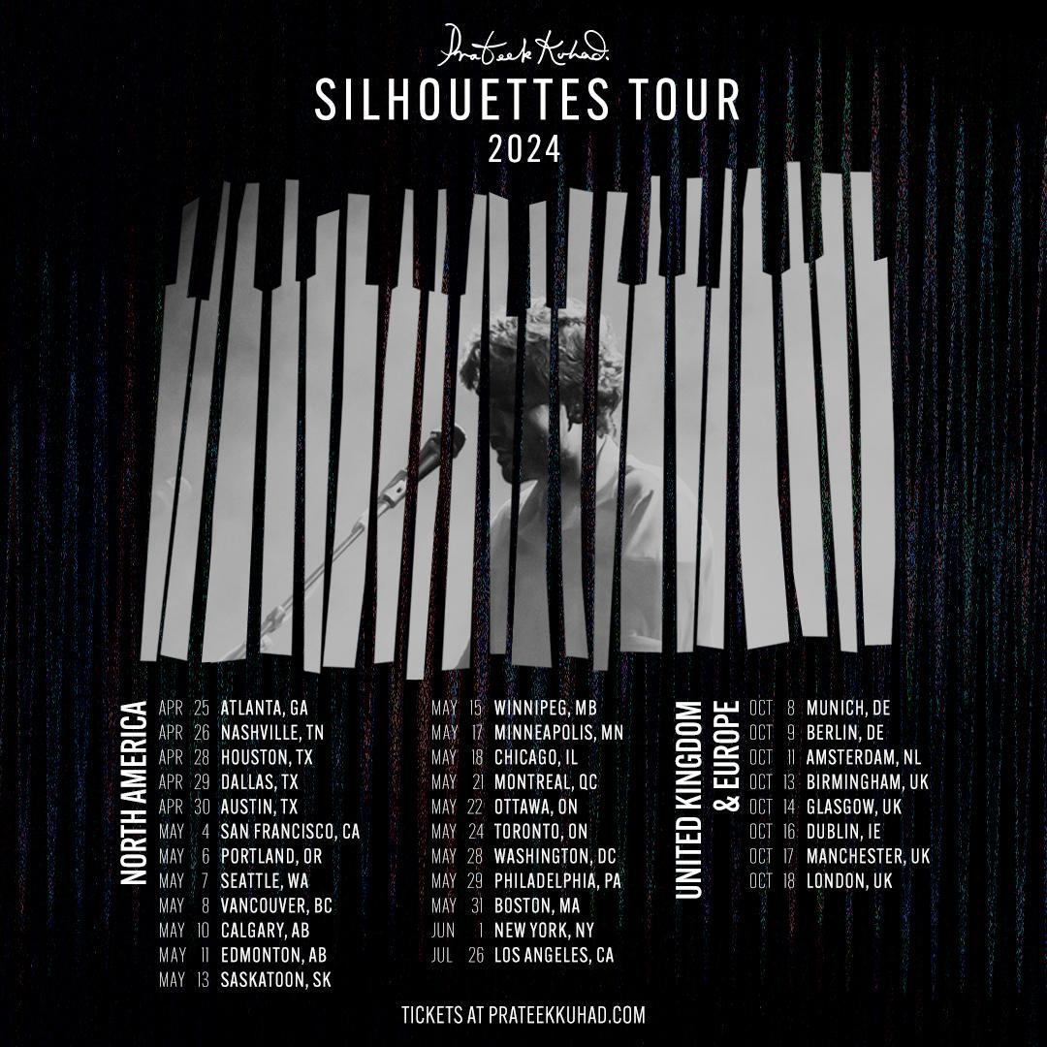
April 25 - Atlanta, GA - Terminal West
April 26 - Nashville, TN - Blue Room at Third Man
April 28 -Houston, TX - White Oak Music Hall
April 29 - Dallas, TX - Granada
April 30 - Austin, TX - Scoot Inn
May 4 - San Francisco, CA - Masonic
May 6 - Portland, OR - Aladdin Theater
May 7 - Seattle, WA - Moore
May 8 - Vancouver, BC - Commodore
May 10 - Calgary, AB - MacEwan Ballroom
May 11 - Edmonton, AB - Midway
May 13 - Saskatoon, SK - Coors Event Center
May 15 - Winnipeg, MB - The Park
May 17 - Minneapolis, MN - Cedar
May 18 - Chicago, IL - Thalia Hall
May 21 - Montreal, QC - Bar le Ritz
May 22 - Ottawa, ON - Bronson Centre
May 24 - Toronto, ON - History
May 28 - Washington, DC - 9:30 Club
May 29 - Philadelphia, PA - Theatre of Living Arts
May 31 - Boston, MA - Royale
June 1 - New York, NY - Beacon Theatre
July 26 - Los Angeles, CA - Venue TBA

Prateek Kuhad
“No Complaints”
AVAILABLE NOW

CONNECT WITH PRATEEK KUHAD
www.prateekkuhad.com
YOUTUBE
INSTAGRAM
FACEBOOK
TWITTER

CONTACT:
Sarah Goldstein
SarahGoldstein@elektra.com

