FALL OUT BOY RELEASES NEW MUSIC VIDEO FOR “SO MUCH (FOR) STARDUST”

FEATURING SURPRISE JIMMY BUTLER CAMEO

WATCH HERE

SO MUCH FOR (2OUR) DUST SOLD OUT TOUR KICKS OFF TONIGHT

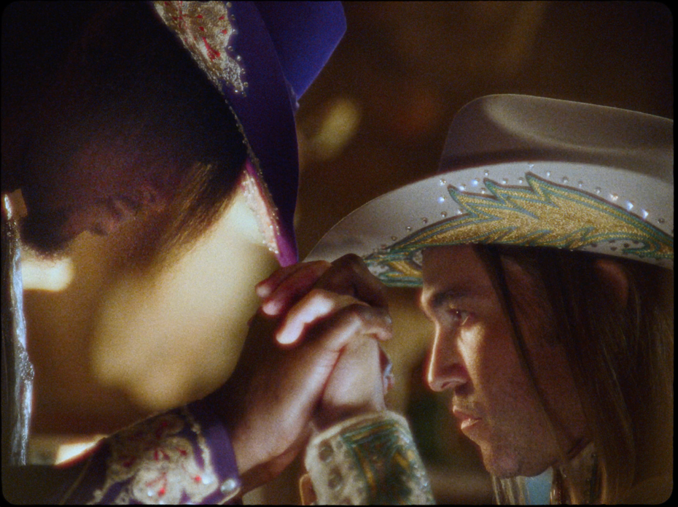

February 28, 2024 – Today, GRAMMY Award-nominated and multi-platinum selling rock band Fall Out Boy released a new music video for “So Much (for) Stardust” – the title track off their most recent album. The video stars six-time NBA All-Star, Miami Heat forward, Jimmy Butler in a surprise cameo. You can watch the video here.

Fall Out Boy is about to kick off their highly anticipated So Much For (2our) Dust global headline tour, a continuation of their incredibly successful So Much For (Tour) Dust 2023 tour in support of their eighth studio album So Much (For) Stardust, which debuted as the No. 1 Rock Album upon its March 24 release. The tour launches tonight with a show at Moda Center in Portland, OR and will travel through cities including Seattle, Austin, Orlando, Baltimore and Nashville before concluding April 6, 2024 in Minneapolis, MN. The trek also includes a sold out stop at New York City’s famed Madison Square Garden on March 22, 2024. For all dates and details, visit www.falloutboy.com/tour.

Fall Out Boy – So Much For (2our) Dust – 2024 Dates
*Jimmy Eat World to support on all dates
Date | City | Venue
Wednesday, February 28 | Portland, OR | Moda Center
Friday, March 1 | Seattle, WA | Climate Pledge Arena (SOLD OUT)
Sunday, March 3 | Sacramento, CA | Golden 1 Center
Monday, March 4 | Anaheim, CA | Honda Center (SOLD OUT)
Thursday, March 7 | Fort Worth, TX | Dickies Arena
Friday, March 8 | Austin, TX | Moody Center
Monday, March 11 | Oklahoma City, OK | Paycom Center
Wednesday, March 13 | Birmingham, AL | Legacy Arena at The BJCC
Friday, March 15 | Orlando, FL | Amway Center
Saturday, March 16 | Jacksonville, FL | VyStar Veterans Memorial Arena
Tuesday, March 19 | Raleigh, NC | PNC Arena
Wednesday, March 20 | Baltimore, MD | CFG Bank Arena
Friday, March 22 | New York, NY | Madison Square Garden (SOLD OUT)
Sunday, March 24 | Albany, NY | MVP Arena (SOLD OUT)
Tuesday, March 26 | Grand Rapids, MI | Van Andel Arena (SOLD OUT)
Wednesday, March 27 | Pittsburgh, PA | PPG Paints Arena
Friday, March 29 | Columbus, OH | Schottenstein Center
Saturday, March 30 | Lexington, KY | Rupp Arena
Sunday, March 31 | Nashville, TN | Bridgestone Arena
Tuesday, April 2 | Milwaukee, WI | Fiserv Forum
Wednesday, April 3 | Des Moines, IA | Wells Fargo Arena
Friday. April 5 | Omaha, NE | CHI Health Center Arena
Saturday, April 6 | Minneapolis, MN | Target Center (SOLD OUT)

