SAM MACPHERSON RELEASES EMOTIONAL NEW SINGLE
“I DON’T WANNA SEE YOU TRY”
LISTEN HERE
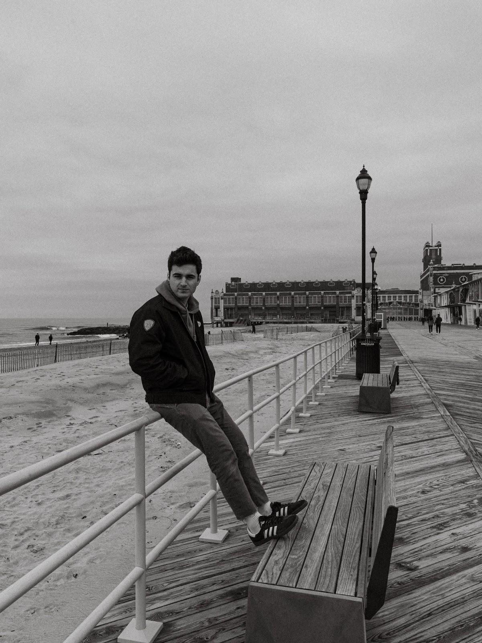
PHOTO CREDIT: MAX GOLDBERG
HI-RES PRESS ASSETS HERE
“…a breath of fresh air in an industry that seems to move at the speed of light.” –LYRICAL LEMONADE
“…breathtaking, smoldering music” –ATWOOD MAGAZINE
“MacPherson's vocals and effortless harmonies blanket you with warmth…” –ONES TO WATCH
“MacPherson accomplishes something that few artists are able to do: He creates a sonic environment that fuels the listener’s introspection.” –EARLY RISING
“He makes this state [NJ] and his worldwide fanbase proud in the way he shares himself through melody, harmony, and artistry.” –THE AQUARIAN WEEKLY
(February 23, 2024) – LOS ANGELES, CA – Acclaimed singer-songwriter and producer Sam MacPherson has released his heartfelt new single “I Don’t Wanna See You Try”. The song is available on all streaming platforms HERE via Elektra. The accompanying visualizer is streaming HERE on Sam’s official YouTube channel. On the track, Sam draws a turbulent scene of frustration, compassion, and a desperate plea for understanding as he dives into the complexities of deeply caring about someone who is seemingly at a breaking point.
On the new single Sam comments, “‘I Don’t Wanna See You Try’ is about the moment a family member told me they didn’t want to be alive anymore. It’s a song that carefully acknowledges the struggles of someone fighting mental health battles, from the point of view of a loved one who couldn’t imagine letting them do it alone. The times I’ve felt the worst about my own mental health were the times I was certain I was struggling alone. Writing this song was me reminding myself that’s never the case.”

SAM MACPHERSON - “I DON’T WANNA SEE YOU TRY”
DOWNLOAD HI-RES SINGLE ART HERE

“I Don’t Wanna See You Try” follows Sam’s 2023 major label debut EP, Powerlines, which is highlighted by singles such as "Safe To Say" and the EP’s title track. Ones To Watch hailed Powerlines as "true fuel for an ascent to stardom" as Lyrical Lemonade praised Sam as "someone who is poised to have a long and illustrious career making music."

Sam MacPherson infuses each lyric and melody with tangible detail. Through a nuanced approach and unclouded lens, the New Jersey-born, Nashville-based artist explores tense goodbyes and doomed relationships in his music, focusing on quiet moments and trepidation. In college, he taught himself how to play guitar, produce, write songs, and record on his own, approaching music with the same grit and determination he brought to athletics as a division 1 soccer player.

Following early uploads such as “No Bad Memories,” he gained traction with the alluring, heartbreaking single “Routine” in 2021. Beyond landing on coveted playlists, it generated 6M+ streams and garnered praise among music blogs. He also served up the Songs for Sam EP featuring his song “Last Minute,” which lit up TikTok and surpassed 10M streams. Through his effortless harmonies and unique perspectives, he carried this momentum into 2022 with singles like “Crash Course” and “Rookie.” Simultaneously, he emerged as a sought-after collaborator behind-the-scenes for Stephen Sanchez, Jonah Kagen, Garrett Nash, and more. He notably co-wrote “Heartbreak Hall of Fame '' for Quinn Lewis and “You” for VINCINT. Moreover, he has shared stages with Jeremy Zucker, Chelsea Cutler, The Brook & The Bluff and labelmate Jake Scott.

Be on the lookout for more from Sam MacPherson soon.

CONNECT WITH SAM MACPHERSON:
Website | Facebook | X | Instagram | TikTok | YouTube

# # #

PRESS CONTACTS:
Sydney Worden | Sydney.Worden@300Elektra.com
Destiny Dominguez | Destiny.Dominguez@300Elektra.com

