TWENTY ONE PILOTS
RETURN WITH DETAILS OF NEW ALBUM CLANCY

SHARE LEAD SINGLE & MUSIC VIDEO - “OVERCOMPENSATE”

ALBUM PRE-ORDERS AVAILABLE TODAY

CLANCY ARRIVES MAY 17TH

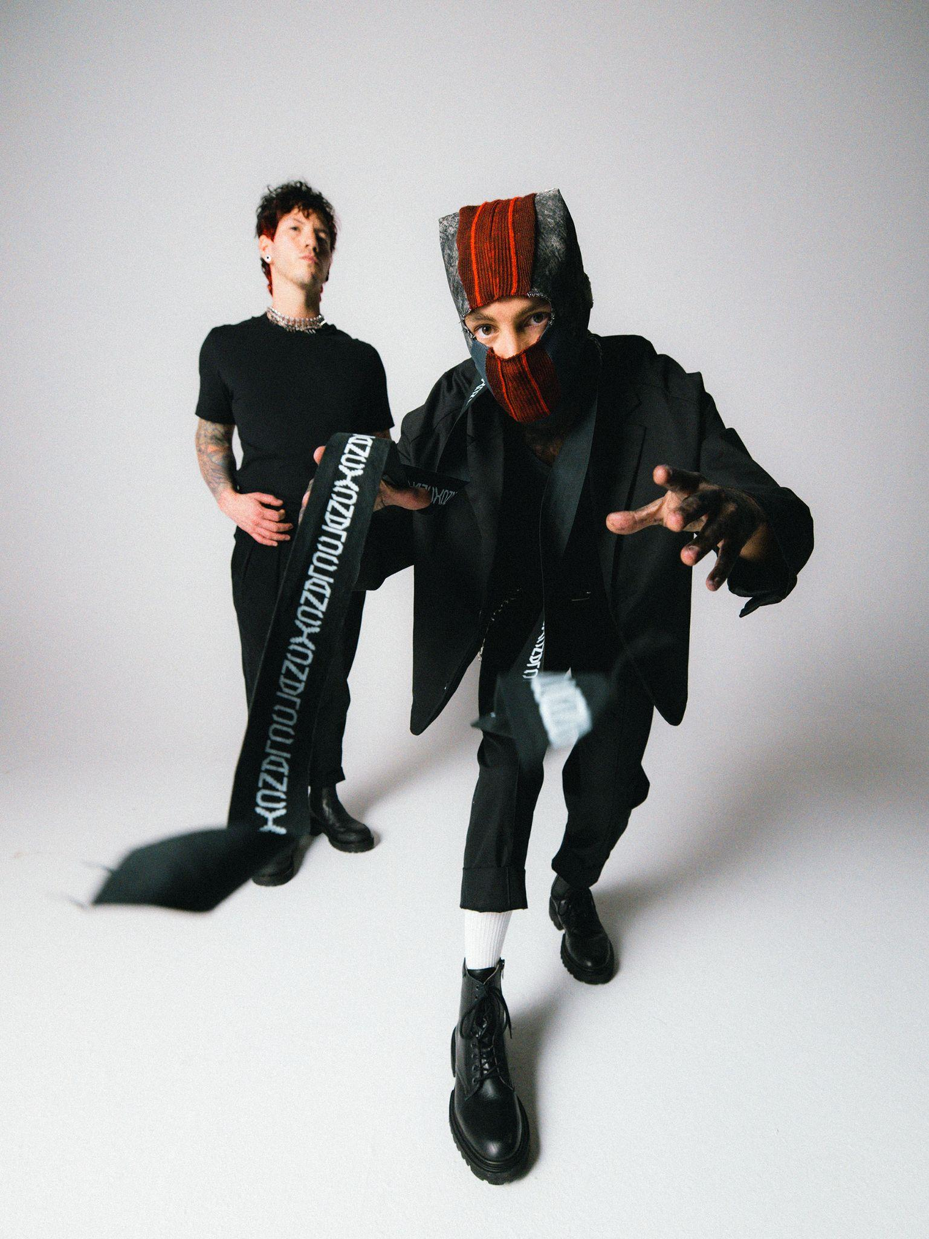
PHOTO CREDIT: ASHLEY OSBORN

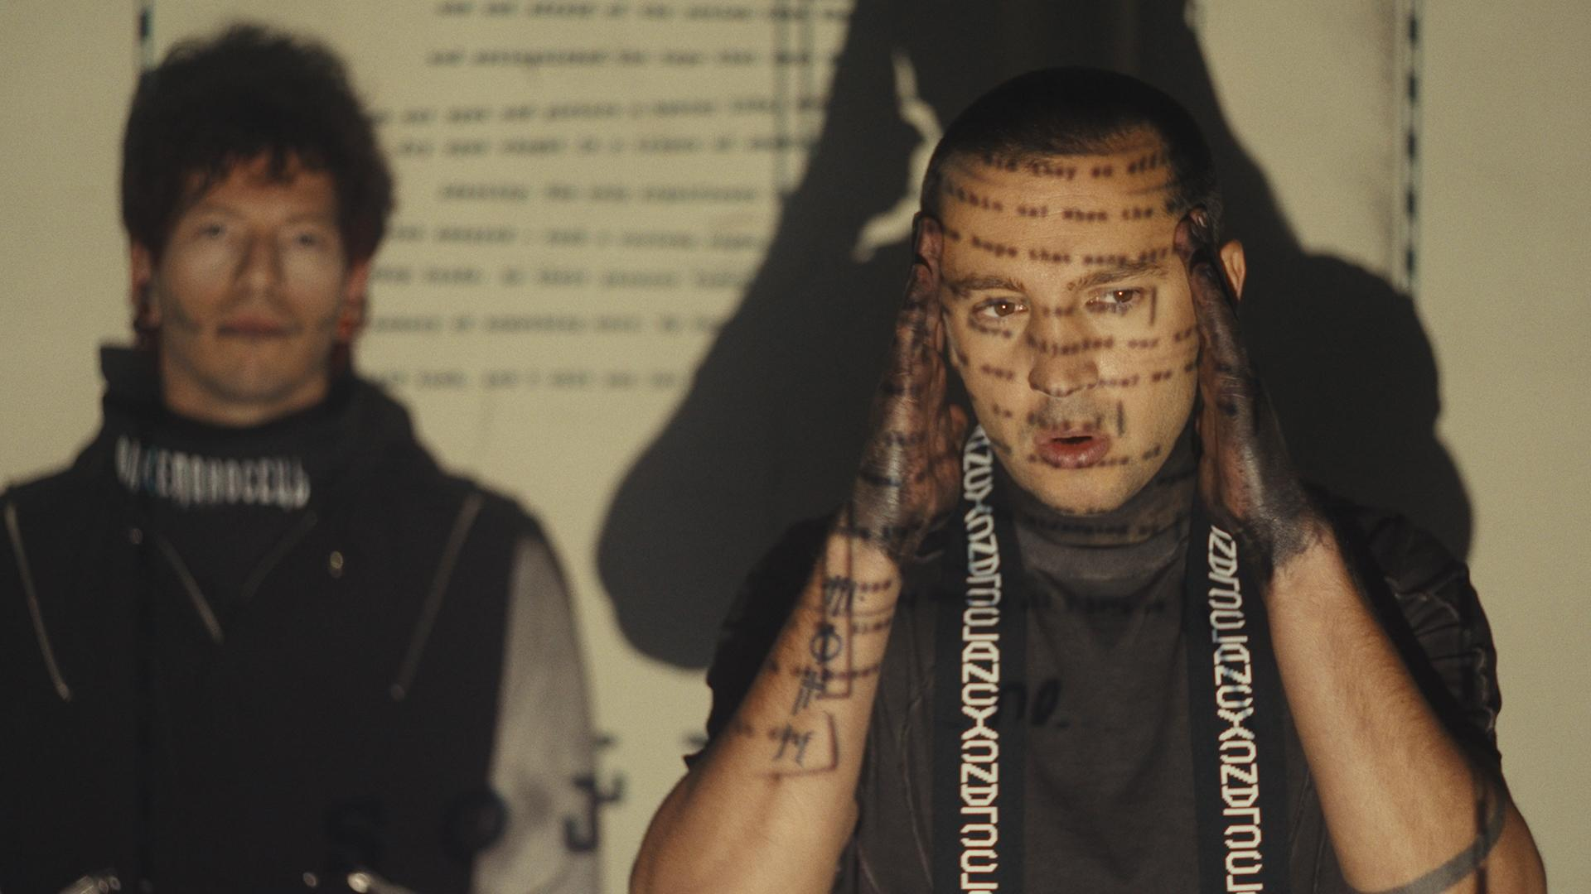
TWENTY ONE PILOTS - “OVERCOMPENSATE”

FEBRUARY 29, 2024 – GRAMMY® Award winning duo Twenty One Pilots have announced details of their new album, Clancy, which will be released May 17th via Fueled By Ramen [album artwork / tracklist below]. Today, the band has shared the forthcoming album’s first single, “Overcompensate,” which is available on all streaming platforms and accompanied by an official music video directed by longtime collaborator Reel Bear Media. Clancy marks Twenty One Pilots’ first studio album in three years and follows their RIAA Gold certified LP, Scaled And Icy.

With details of the release teased to fans earlier this month via cryptic mailings and covert artswaps on streaming services, “Overcompensate” welcomes listeners back to the band’s immersive world of ‘Trench.’ Layers of synths build over a racing breakbeat in the song - a skilled passage of alternative dynamics, flexing in time, and ready to explode.

Introducing a new era of Twenty One Pilots, Clancy is available for pre-order today in a variety of physical formats including: two limited-edition deluxe box sets, four vinyl variants with additional retailer exclusives, an exclusive CD + Journal Book and a Cassette + Photocard Wallet, and much more. For the full suite of Clancy pre-order offerings, visit Twenty One Pilots’ official store.

Having amassed over 33 billion streams worldwide and over 3 million tickets sold across global headline tours, the Columbus, OH based duo of Tyler Joseph and Josh Dun have established themselves as one of the most successful bands of the 21st century and redefined the sound of a generation. Co-produced by Joseph and Paul Meany, Clancy marks the final chapter in an ambitious multi-album narrative first introduced in the band's 2015 multi-Platinum breakthrough, Blurryface. Furthermore, Clancy’s forthcoming release on May 17th coincides with the 9th anniversary of Blurryface, which was released exactly nine years prior to the day.

Twenty One Pilots extended the ambitious concept laid out in Blurryface with their 2018 Platinum-certified album TRENCH. Featuring the multi-Platinum and Platinum singles “Chlorine,” “My Blood” and the GRAMMY® Award-nominated “Jumpsuit,” the album graced spots on “Best of” year-end lists by Billboard, KERRANG!, Alternative Press, and Rock Sound—who placed it at #1.

The duo’s 2021 epic Scaled And Icy debuted at No. 1 on Billboard's Top “Rock Albums” and “Alternative Albums” charts while landing at No. 3 on the “Billboard 200,” marking the biggest opening week for a rock album in 2021. The record is highlighted by the #1 Alternative Radio hits “The Outside,” “Saturday,” and “Shy Away,” the latter of which ascended to #1 at the format in just three weeks, placing the duo in an elite group of acts with multiple songs to rise to #1 at the format in three weeks or less including: U2, R.E.M., The Cure, Linkin Park, Red Hot Chili Peppers, and Foo Fighters.

[Album Artwork / Tracklisting Below]

Twenty One Pilots
Clancy
Pre-orders Available Here: http://top.lnk.to/Clancy

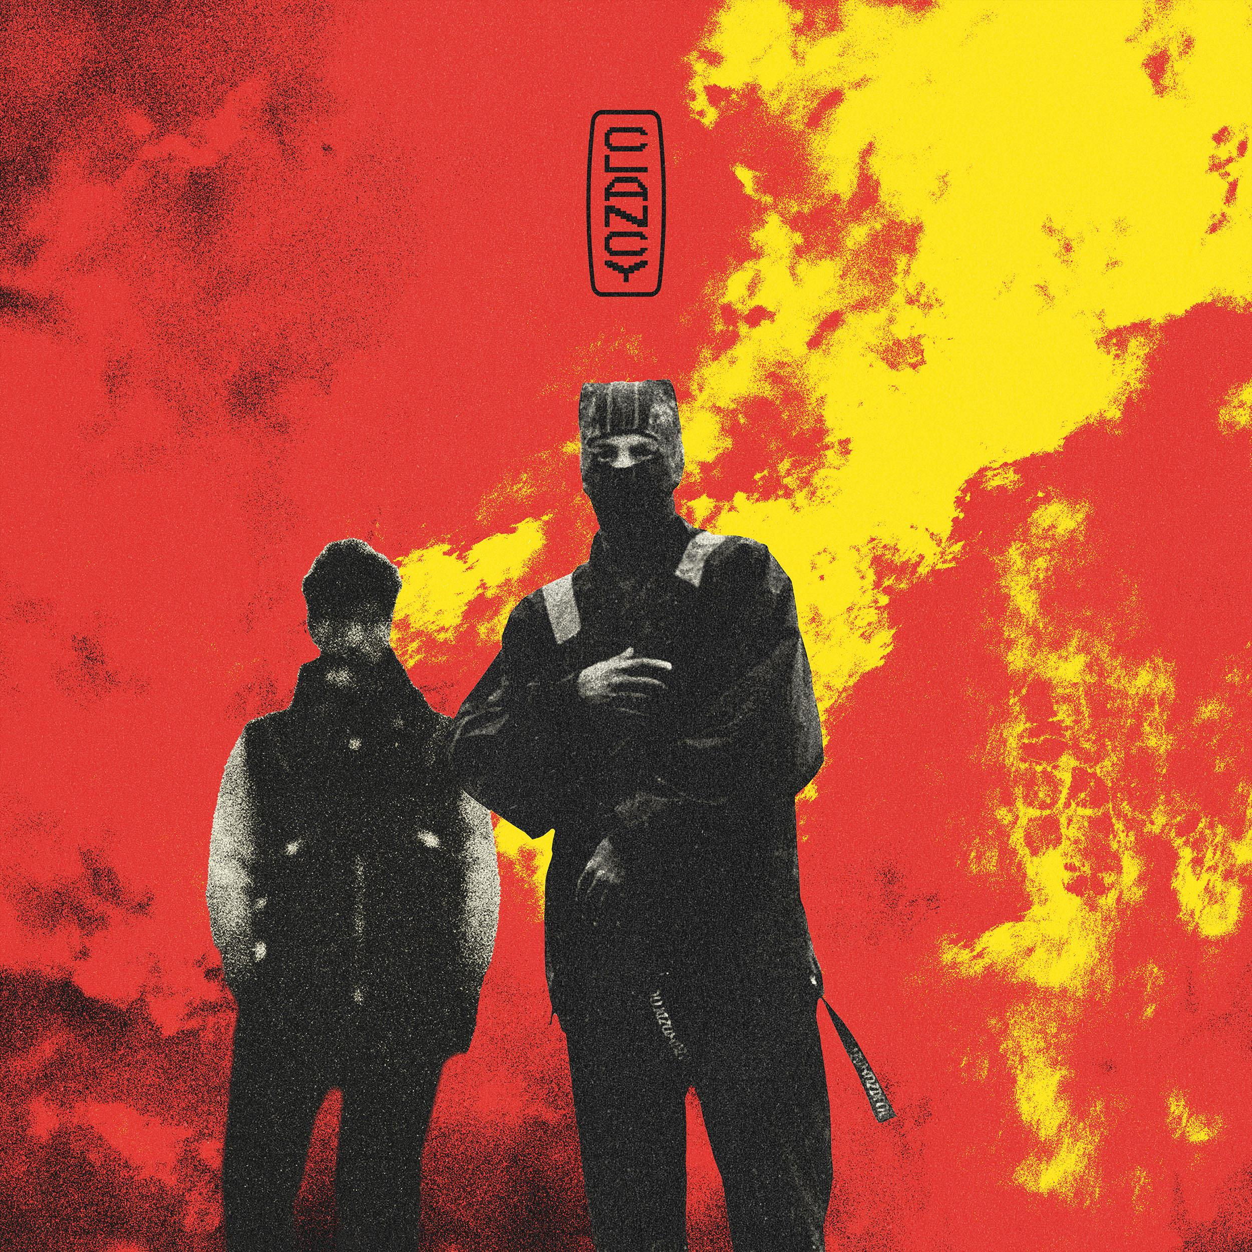

1. Overcompensate
2. Next Semester
3. Midwest Indigo
4. Routines In The Night
5. Backslide
6. Vignette
7. The Craving (Jenna’s Version)
8. Lavish
9. Navigating
10. Snap Back
11. Oldies Station
12. At the Risk Of Feeling Dumb
13. Paladin Strait

About Twenty One Pilots:
Grammy-Award winning band, Twenty One Pilots, have shifted music and culture as an incomparable creative force and with an ever-evolving vision. The Columbus, OH duo—Tyler Joseph and Josh Dun— have tallied over 33 billion global streams and counting, sold north of three million tickets worldwide, notched dozens of multi-Platinum certifications, and even claimed a spot in the Guinness® Book of World Records. In historic fashion, their quadruple-Platinum breakout LP, Blurryface, took flight as “the first album to notch a RIAA Gold or Platinum certification for every one of its songs,” while Vessel followed suit and achieved the same distinction. They elevated to rarified air as “one of only 18 artists to earn multiple RIAA Diamond certifications,” going Diamond with “Stressed Out” and “Heathens.” 2018’s Platinum-certified Trench extended the ambitious concept laid out in Blurryface and delivered the multi-Platinum and Platinum singles: “Chlorine,” “My Blood” and the GRAMMY® Award-nominated “Jumpsuit.” They followed Trench with their Gold-certified LP Scaled And Icy, achieving “the biggest opening week for a rock album in 2021” by capturing #1 on the Billboard Top Rock Albums and Top Alternative Albums charts and crashing the Top 3 of the Billboard 200. Beyond rapturous headline shows at arenas and festivals worldwide, Twenty One Pilots have notably architected an immersive world without comparison, originating a multi-album conceptual arc across Blurryface, Trench, and Scaled And Icy. Exactly nine years to the date of the Blurryface album release, they complete this story on their seventh full-length offering, Clancy [Fueled By Ramen], out May 17, 2024. Led by the single “Overcompensate,” the LP signals the dawn of another era for Twenty One Pilots and alternative rock music at large.

###

For more information on Twenty One Pilots, contact:
Ross Anderson | Ross.Anderson@300Elektra.com

Follow Twenty One Pilots:
Official | TikTok | Instagram | Twitter | YouTube | Facebook

