FOR IMMEDIATE RELEASE
March 1, 2024

BENDIGO FLETCHER RELEASE NEW SINGLE “SWEET TOOTH” TODAY
LISTEN HERE

SOPHOMORE ALBUM TWO THINGS AT ONCE ARRIVES MARCH 22
PRE-ORDER/PRE-SAVE HERE

33-CITY NORTH AMERICAN TOUR BEGINS NEXT WEEK MARCH 8
TICKETS AVAILABLE HERE

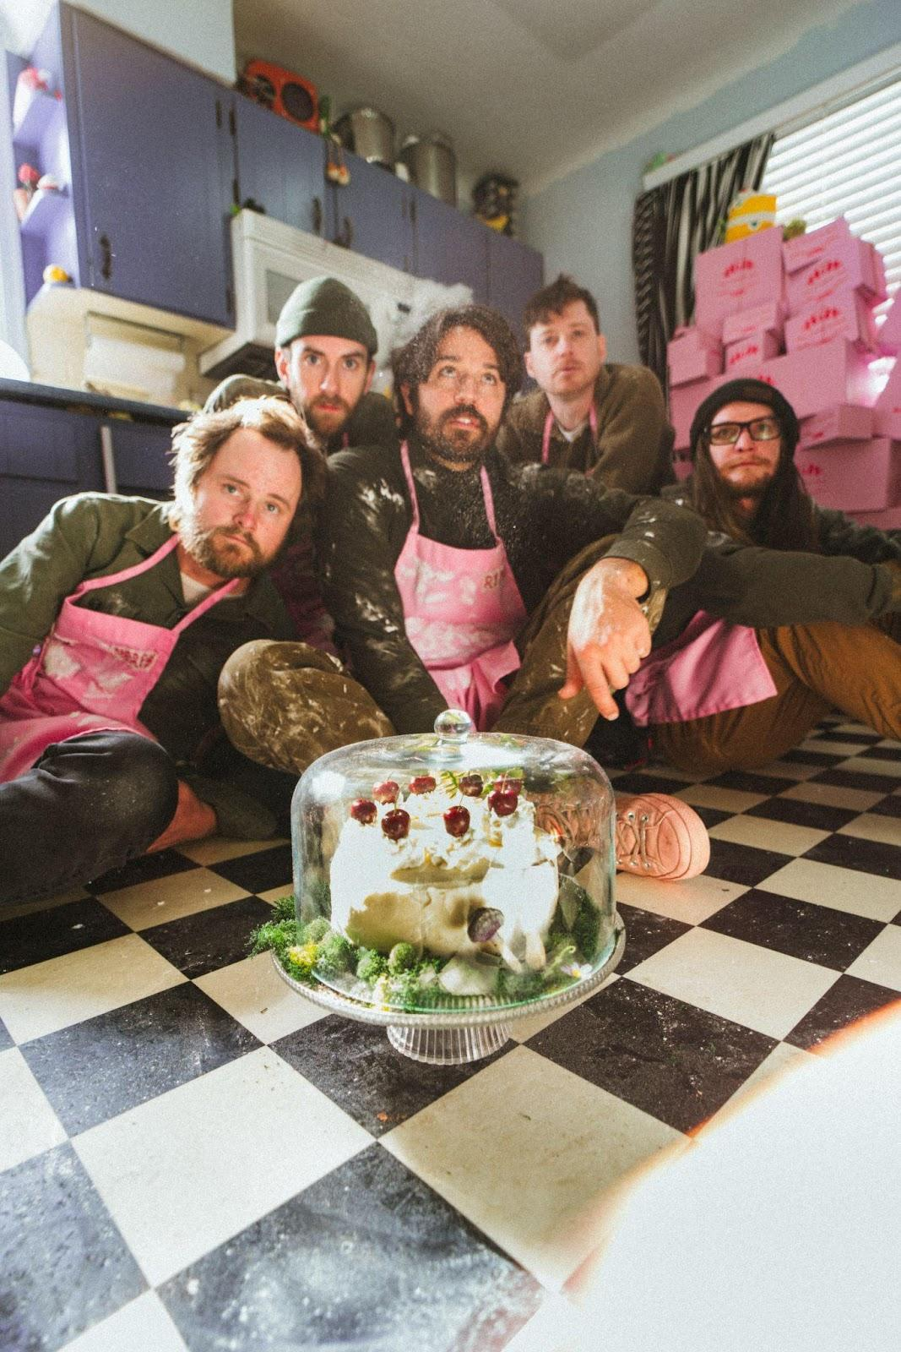
Photo Credit: Ben Baptist

Louisville, KY’s Bendigo Fletcher have unveiled a new single entitled “Sweet Tooth”. The track is available on all streaming platforms beginning today HERE. Watch the song’s accompanying visual HERE. “Sweet Tooth” marks the second song Bendigo Fletcher have shared from their forthcoming sophomore album Two Things At Once, which is due for release on March 22, 2024 via Elektra. The album is available for pre-order/pre-save on all streaming platforms now HERE.

On “Sweet Tooth,” delicate acoustic guitar brushes up against pensive verses as lead vocalist/guitarist Ryan Anderson exhales, “I’ve had enough of all this.” Once the electric guitar and shimmering piano kick in, the momentum picks up on a falsetto-inflected refrain, “No sleep till the money.” Sporting “a sour sense of humor,” it takes aim at the systemic inequality between the haves and the have-nots.

Anderson shares, “That song comes from trying to not let the situation steal from us what makes us human — to scrape for compassion for the world and in our relationships, to make music, to cry together, to not let the fight for freedom take our joy. When life is sad, there is beauty in coming together and sharing perspective.”

Two Things At Once pulls together threads of folk, psychedelia, indie, alt-country, and rock into a charcuterie board of vibrant characters, vivid memories, and vital moments. It’s a recipe for 11 intoxicating and irresistible anthems earmarked by American Songbook-worthy storytelling and elevated songcraft. For the album, they notably reteamed with producer Ken Coomer [a founding member of Wilco and Uncle Tupelo], recording at Cartoon Moon Recording in Nashville and at Southern Grooves in Memphis joined by GRAMMY® Award-winning engineer Matt Ross-Spang [Jason Isbell, John Prine, Margo Price].

Bendigo Fletcher ushered in Two Things At Once with the February release of lead single “Upcountry Lemonade”, which arrived to praise from Ones To Watch, Atwood Magazine, and more. Watch the track’s accompanying visual HERE. Last weekend, Bendigo Fletcher personally previewed Two Things At Once for a group of 20 fans at a secluded hideaway in the woods outside of Louisville. This cohort of listeners joined the band for a hike to the house where they heard the album in its entirety and enjoyed an unforgettable stripped-down live performance.

In support of the album, Bendigo Fletcher will embark on a North American headline tour this spring. The 33-city trek kicks off on March 8 in Indianapolis, visits major markets coast-to-coast, and wraps on May 11 in Cincinnati. Get tickets HERE. Last year, Bendigo Fletcher supported The Backseat Lovers on their Waiting To Spill Summer Tour. They also joined The Brook & The Bluff on a 7-week run which saw them perform to sold out crowds across North America. As a powerhouse live presence, the band has previously toured supporting Caamp, Mt. Joy, Rainbow Kitten Surprise, Shakey Graves, Madison Cunningham, and more.

Last fall, Bendigo Fletcher surprised fans with a cover of Cults’ 2011 classic “Go Outside”. “Go Outside (From Natural Bridge State Resort Park)” is available to stream and download HERE via Elektra. Recorded live at Slade, KY’s Natural Bridge State Resort Park, the release was accompanied by a stunning visual of the band performing the song in the picturesque location. Watch HERE. Bendigo Fletcher encourages fans to support the Kentucky State Parks Foundation, a non-profit organization aimed at connecting residents and guests to the outdoors. The band also partnered with Kentucky Parks Club on a limited edition t-shirt, designed by frontman Ryan Anderson. The shirt is available now HERE.

"Go Outside (From Natural Bridge State Resort Park)" marked Bendigo Fletcher’s first new music since the 2023 Fourth of July single ”Uncle Mick’s Fireworks Extravaganza" and their 2022 Wingding EP. Praised for their blend of folk-rock and psychedelic twang, the band garnered acclaim from publications like MUD and Consequence. Their debut album, Fits Of Laughter, released in 2021, featured hits like "Sugar In The Creek" and "Evergreen," earning accolades from FLOOD Magazine, Music Connection, American Songwriter, and Atwood Magazine for its unique blend of alt-rock and folk-Americana roots.

BENDIGO FLETCHER - TWO THINGS AT ONCE
PRE-ORDER HERE | STREAM “SWEET TOOTH” HERE

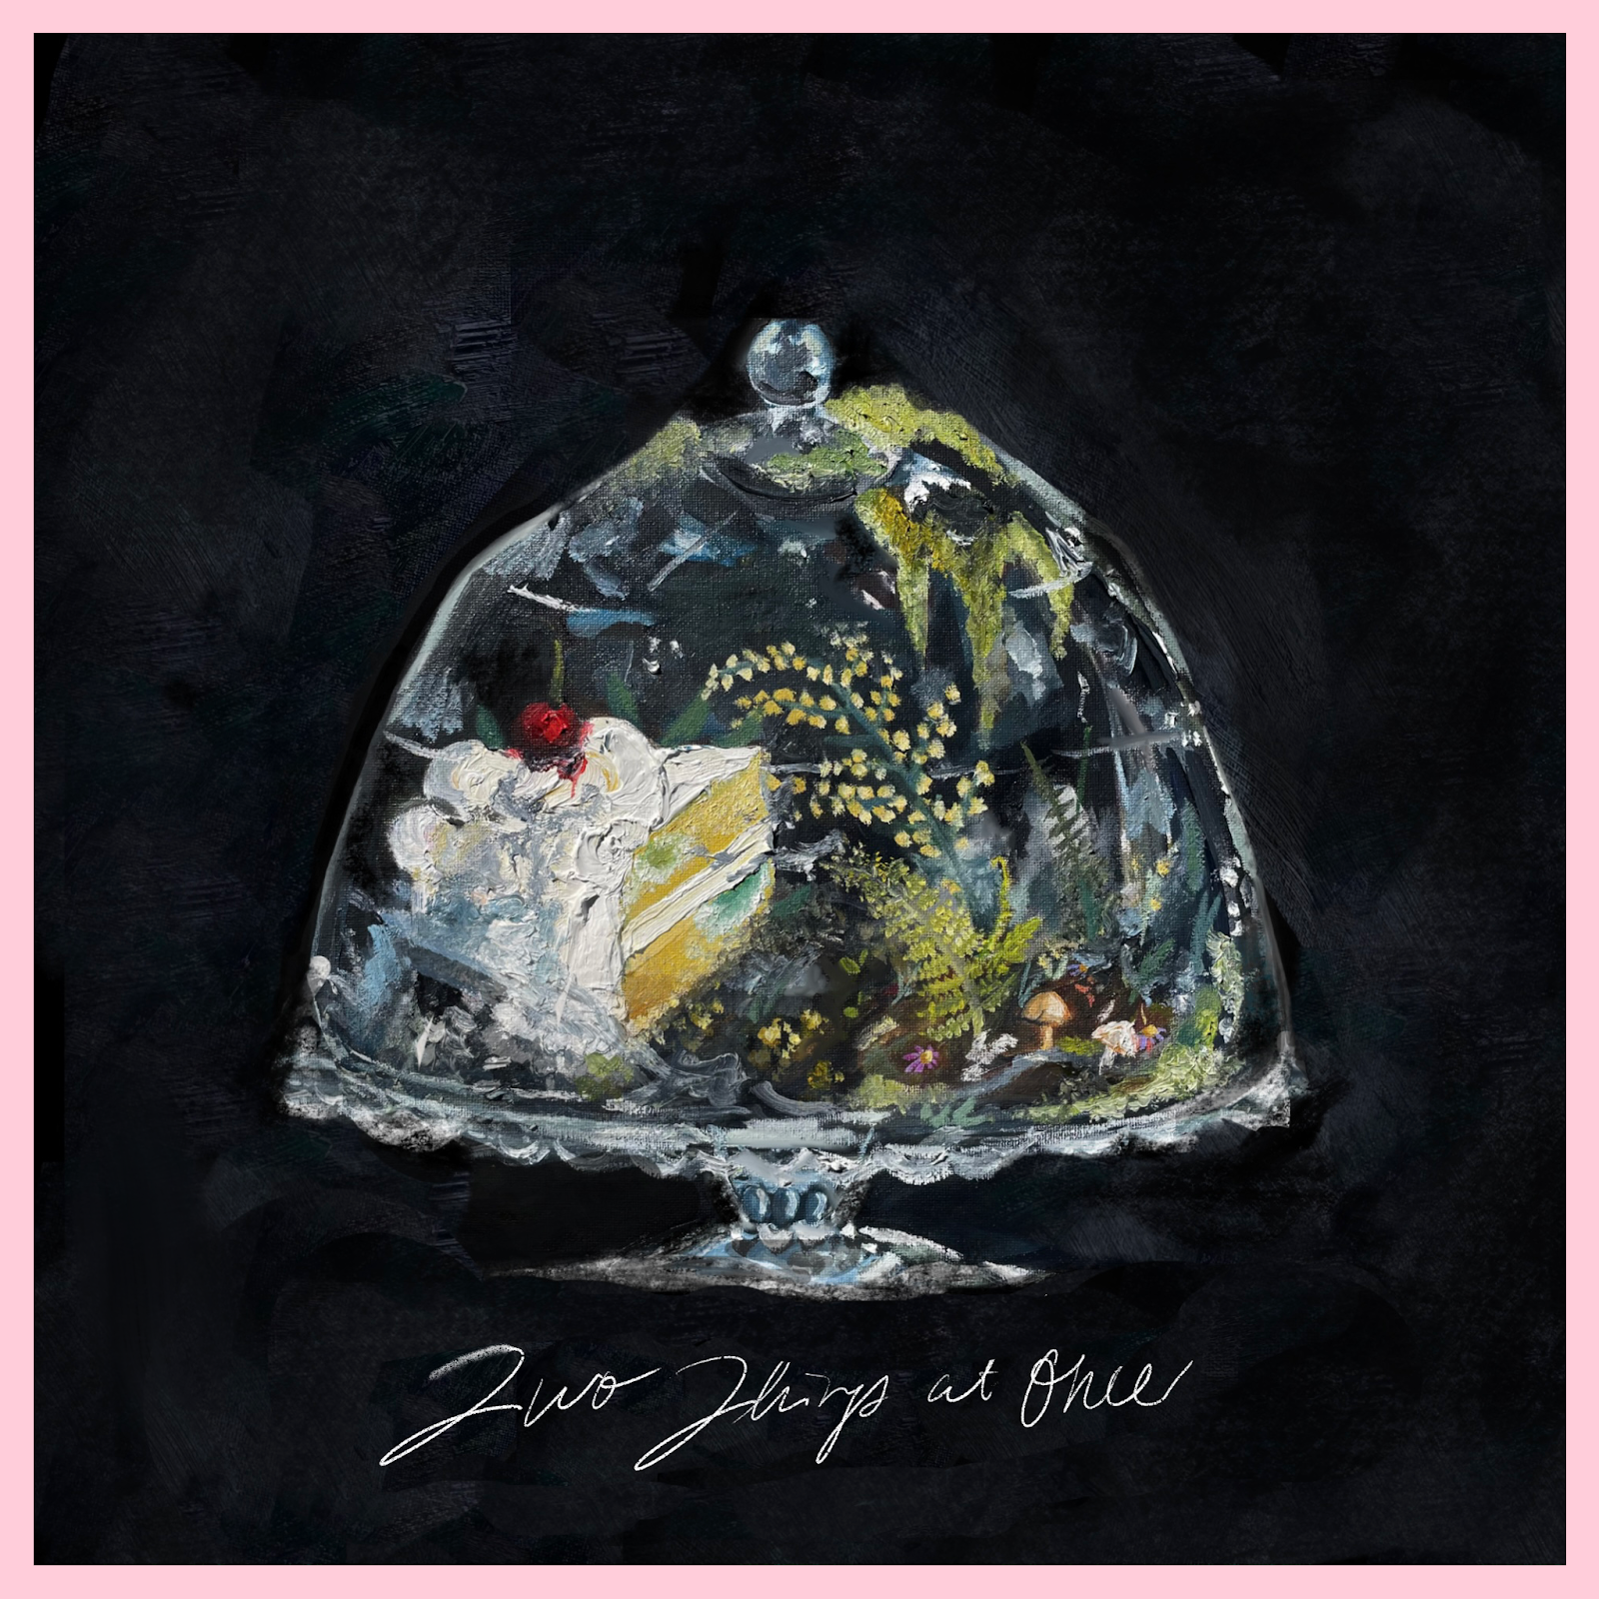

Bendigo Fletcher Tour Dates
March 08, 2024 - Indianapolis, IN - HI-FI Indy
March 09, 2024 - St. Louis, MO - Blueberry Hill
March 16, 2024 - Dallas, TX - Tulips
March 21, 2024 - Nashville, TN - Basement East
March 22, 2024 - Atlanta, GA - Masquerade (Purgatory)
March 23, 2024 - Asheville, NC - Grey Eagle
March 24, 2024 - Carrboro, NC - Cat’s Cradle Backroom
March 26, 2024 - Washington, DC - DC9
March 28, 2024 - Asbury, NJ - Wonder Bar
March 29, 2024 - New York, NY - Sultan Room
March 30, 2024 - Boston, MA - Cafe 939
March 31, 2024 - Portland, ME - Portland House of Music
April 02, 2024 - Toronto, ON - The Garrison
April 04, 2024 - Columbus, OH - Woodlands
April 05, 2024 - Louisville, KY - Headliners Music Hall
April 06, 2024 - Chicago, IL - Lincoln Hall
April 08, 2024 - Madison, WI - High Noon Saloon
April 09, 2024 - Minneapolis, MN - Amsterdam
April 12, 2024 - Billings, MT - Pub Station
April 15, 2024 - Boise, ID - Shrine Social Club
April 16, 2024 - Salt Lake City, UT - Kilby Court
April 18, 2024 - Denver, CO - Bluebird Theater
April 20, 2024 - Boulder, CO - Bluebird Music Festival*
April 21, 2024 - Fort Collins, CO - Aggie Theatre
April 23, 2024 - Great Falls, MT - The Newberry
April 25, 2024 - Seattle, WA - Barboza
April 26, 2024 - Portland, OR - Doug Fir
April 28, 2024 - San Francisco, CA - Bottom of the Hill
May 01, 2024 - Los Angeles, CA - Moroccan Lounge
May 02, 2024 - San Diego, CA - Soda Bar
May 04, 2024 - Santa Fe, NM - Meow Wolf
May 07, 2024 - Oklahoma City, OK - Ponyboy OKC
May 11, 2024 - Newport, KY - Southgate House Revival
*Festival Appearance

Bendigo Fletcher is: Ryan Anderson (lead vocals, guitar, banjo) - Andrew Shupert (backing vocals, lead guitar) - Evan Wagner (backing vocals, keys, guitar, auxiliary percussion) - Conner Powell (bass) - Chris Weis (drums).

BendigoFletcher.com
Facebook | Instagram | Twitter | YouTube

Bendigo Fletcher press contact:
Collin Citron | collin.citron@300elektra.com
Destiny Dominguez | destiny.dominguez@300elektra.com

