HANNAH GRAE RELEASES NEW MINI ALBUM
NOTHING LASTS FOREVER
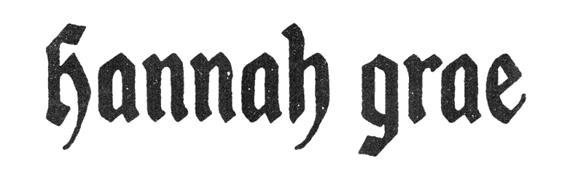
INCLUDES NEW SONG “WHEN I HAD HOPE I HAD IT ALL”

LISTEN HERE

DOWNLOAD PRESS ASSETS HERE

March 15th, 2024 - Today, breakout star Hannah Grae has shared her highly anticipated mini album Nothing Lasts Forever, available now on all streaming platforms HERE. The nine-track collection, co-written with producer Rob Brinkmann, shows the self-taught musician at her best as she holds nothing back. Drawing influence from the likes of Courtney Love, Green Day, and Phoebe Bridgers, Nothing Lasts Forever includes five brand new songs as well as previously released singles "Screw Loose", "Who Dunnit?", "It Could've Been You", and "Better Now You're Gone", the latter of which Rolling Stone hailed as a “song you need to know”.

Speaking on her new mini album, Hannah comments: “I’m so excited to finally be releasing Nothing Lasts Forever. I wrote it when I was 19 and freshly new to London. I remember feeling like I was treading water trying to take everything in and appreciate it all. 19 was such a transformative year for me, as it is for a lot of people. I couldn’t really figure out how I fitted into this new world that I was now a part of. This meant that I struggled with being authentic and knowing exactly who I was and the only thing that felt like me at this time, was my music. The project is about so many things. It’s about growth, grief, breakups, and breakdowns. I poured everything I had into it and I’m so proud of what came from that.”

A standout moment on Nothing Lasts Forever is closing track “When I Had Hope I Had It All”, which sees Hannah channel Paramore’s Hayley Williams as she showcases her incredible vocal ability. Commenting on “When I Had Hope I Had It All”, Hannah adds: “’When I Had Hope I Had It All’ is one of my favourite songs I’ve ever written. It explains the whole project in one song and it was the first concept idea I had for this mini album. I had written the title in my notes app months before I’d even started the writing process. I knew that it struck a nerve in me, and I felt something every time I thought about it. The song is about dreaming so big and so much and then finally achieving your dream, or at least parts of it, and it not being what you thought it would be. A fantasy is only that when it’s being fantasised about. So much magic was lost when I forgot why I was working so hard to get to where I wanted. I often listen to this song to remind myself of why I’m doing this, which is why I think it’s the perfect closing track for the project.”

NOTHING LASTS FOREVER TRACKLIST:
1. The Overture
2. Typical (The Buttercup Song)
3. Better Now You’re Gone
4. Need Me Now
5. It Could’ve Been You
6. Screw Loose
7. Number 4
8. Who Dunnit?
9. When I Had Hope, I Had It All
Named an artist to watch by Rolling Stone UK, NME, Dork, and The Independent, Hannah began captivating online audiences with her rewrites of popular songs and covers posted from her garden shed, resulting in over 146k subscribers to her YouTube channel and 275k followers on TikTok. Merging nostalgic elements of No Doubt, Courtney Love, Alanis Morrisette, and The Bangles and modern earnest storytelling lyrics inspired by the likes of Phoebe Bridgers, Hayley Williams, and Taylor Swift – Hannah’s self-taught musical education seats her firmly in the lineage of cross-genre women making musical waves.

Having only released her first body of work, Hell Is A Teenage Girl, last year, Hannah Grae has impressed crowds across the UK and Europe with performances at Glastonbury, 2000Trees Festival, The Great Escape, Neighbourhood Weekender, Liverpool Sound City, Focus Wales, Standon Calling Festival, Rock En Seine (Paris), Sziget Festival (Budapest), Mad Cool Festival (Madrid), Pukkelpop Festival (Belgium), Reading & Leeds Festival, and All Points East to name a few. Today’s arrival of Nothing Lasts Forever promises 2024 to be even more explosive.
DOWNLOAD PRESS PHOTO HERE
Photo Credit: Megan Winstone

Follow Hannah Grae on socials:
INSTAGRAM | TWITTER | YOUTUBE | TIKTOK

For Hannah Grae press enquiries:
sydneyworden@elektra.com

