LEGENDARY UKRAINIAN BAND OKEAN ELZY
SIGNS GLOBAL MAJOR LABEL DEAL WITH WARNER MUSIC

SHARES NEW SINGLE “VOICES ARE RISING”

LISTEN HERE

DOWNLOAD HI-RES PRESS ASSETS HERE

(MARCH 22, 2024) - Ukraine's most beloved and enduring band, Okean Elzy, is set to make waves on the global music scene with their recent worldwide signing to Warner Music. To herald this announcement, the band has shared their new single “Voices Are Rising.” The song is available now on all streaming platforms. The band are gearing up to release their first album entirely in English, marking a significant milestone in their illustrious career. Okean Elzy, whose name translates to “Elza’s Ocean” and who are renowned for their powerful rock anthems like “На небі“ (“Na Nebi“) and “Без бою“ (“Bez boyu”) have captivated audiences in Eastern Europe for decades.

“’Voices Are Rising’ is a song about energy. Everyone has an enormous amount of energy inside. The challenge is to be able to use this energy for the benefit of good things. It is an important skill I like to use every time I face difficulties. A very necessary song for me and millions of people in these turbulent times,” lead vocalist Sviastoslav Vakarchuk aka “Slava” explains the inspiration behind the emotional rock ballad. Starting off with soft, melodic verses, the song quickly unfolds into an anthemic chorus that perfectly encapsulates the intensity of despair surrounding the grievances of the people of Ukraine and the rest of the world watching in shock.

For over twenty-five years, Okean Elzy has been a beacon of hope and inspiration in Ukraine, spreading their message of resilience and unity through their music. Lead singer Slava has been at the forefront of this movement, using his platform to advocate for peace and solidarity in the face of adversity.

With their upcoming album, Okean Elzy aims to transcend borders and share the rich tapestry of Ukrainian culture with audiences around the world. Their decision to release an English-language album comes at a crucial time, as the ongoing war in Ukraine underscores the importance of international solidarity and understanding.

"It's paradoxical," says Slava, reflecting on the band's journey as a rock musician, “I’ve always believed in the power of love. But when war is going on in your country, threatening the people you love, you have to become a warrior.” Indeed, Slava has been actively involved in performing acoustically for Ukrainian troops at the front lines, using his music to uplift spirits and spread messages of hope to boost morale with hundreds of performances.

Despite English not being their native language, Okean Elzy embrace this new artistic endeavor with enthusiasm and determination. Collaborating with international producers, they are poised to deliver a collection of songs that stay true to their signature sound while reaching a broader audience. "We've always been influenced by English-speaking rock and pop music," explains Slava. "Now, we're excited to share our music with the world in a language everyone can understand."

Fabian Drebes, Co-President of Warner Music Central Europe, says: "I'm delighted to welcome Okean Elzy to the Warner Music Central Europe roster. The band have rocked eastern Europe for years and now the rest of the world is going to fall in love with their sound. I've heard the music from their upcoming album and can tell you that rock fans are in for a real treat."

In addition to their upcoming album release, Okean Elzy is gearing up for a series of solo charity gigs for their Help for Ukraine Tour with gigs in Ukraine, as well as in Malmö, Gothenburg, Brussels, Edinburgh, Birmingham, Manchester, Bristol, and Brighton. The band is furthermore excited to announce two brand new dates: April 30, 2024, in Berlin at the venue Metropol and May 02, 2024, at Warsaw’s Palladium.

Through their music and activism, Okean Elzy continue to spread a message of hope and resilience, reminding audiences that "there is light at the end of the tunnel, we just need to all get through the tunnel and to the light."

OKEAN ELZY - “VOICES ARE RISING”
AVAILABLE NOW
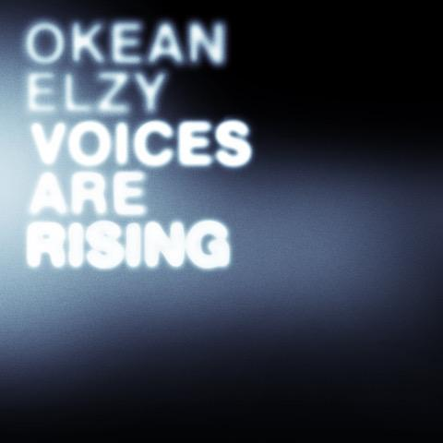

CONNECT WITH OKEAN ELZY
TIKTOK | INSTAGRAM | X | FACEBOOK

PRESS CONTACTS:
Collin Citron - CollinCitron@Elektra.com
Sydney Worden - SydneyWorden@Elektra.com

