RAINBOW KITTEN SURPRISE ANNOUNCE
FIRST NEW ALBUM IN SIX YEARS

LOVE HATE MUSIC BOX ARRIVES MAY 10 VIA ELEKTRA

PRE-ORDER & PRE-SAVE HERE

SHARE NEW SINGLE “SUPERSTAR” ACCOMPANIED BY ITS OFFICIAL MUSIC VIDEO TODAY

LISTEN HERE / WATCH HERE

MAJOR NORTH AMERICAN TOUR TO BE ANNOUNCED SOON

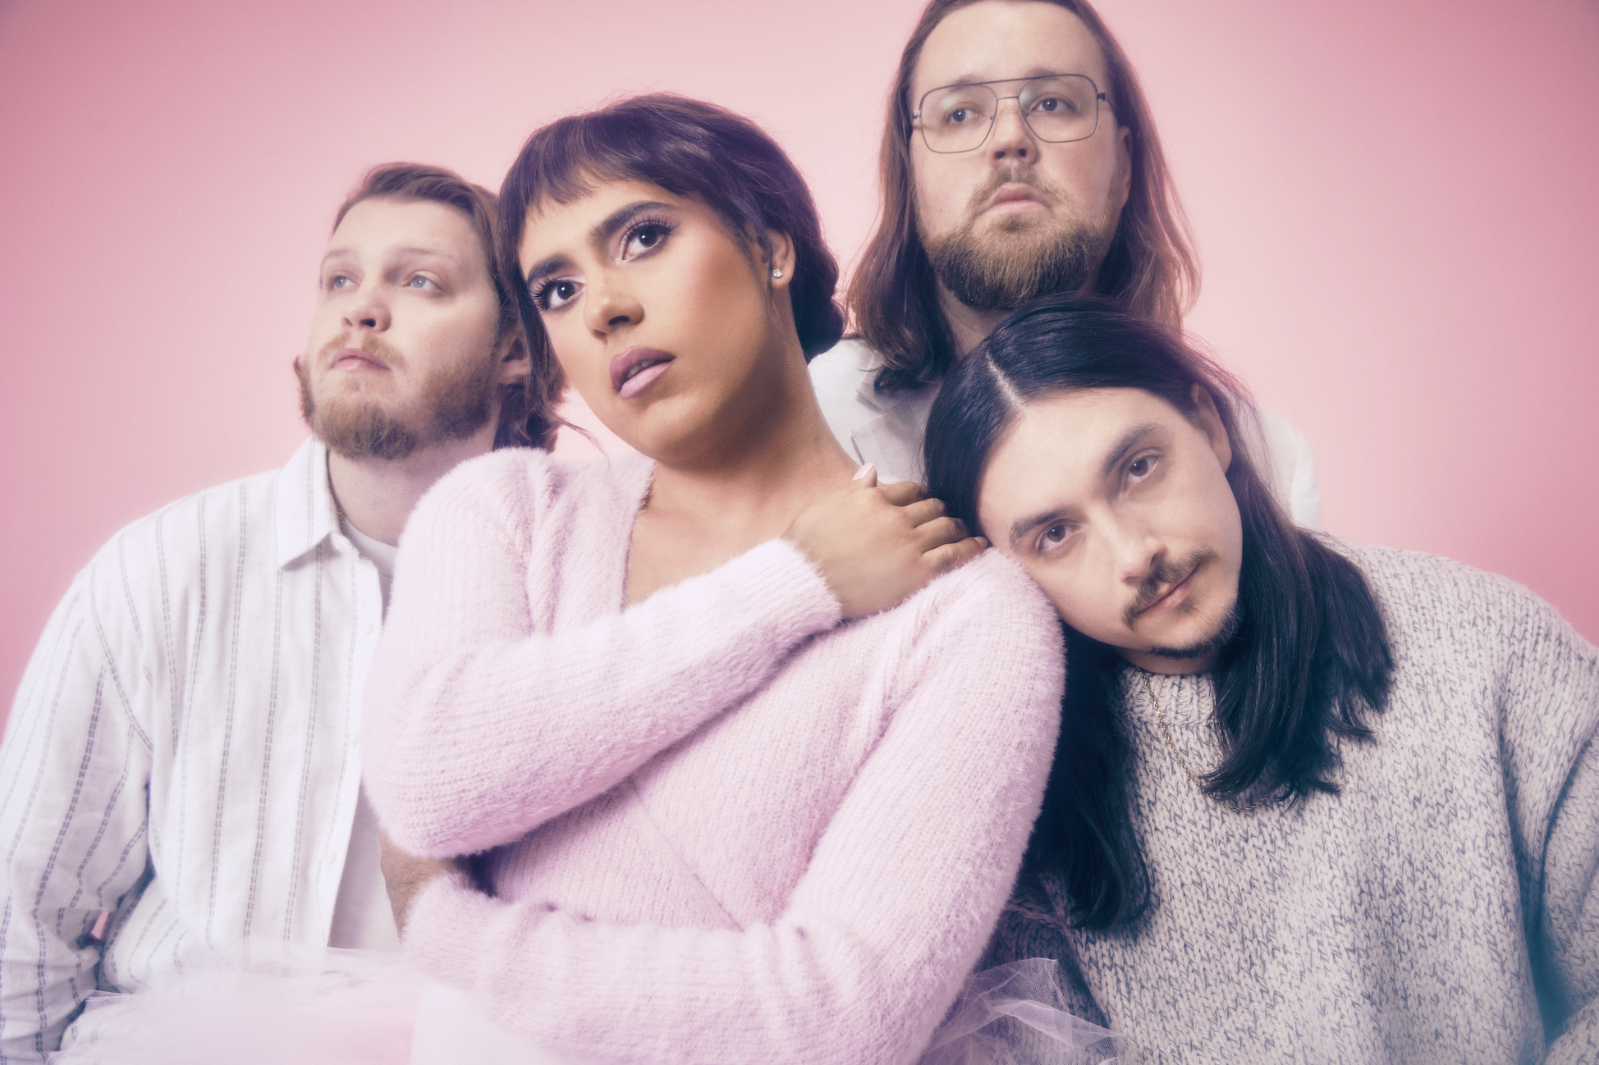
Photo Credit: Jimmy Fontaine

PRESS ASSETS HERE

Making a bold return, genre-defying, North Carolina-bred quartet and live sensations Rainbow Kitten Surprise will unveil their first full-length album in six years, LOVE HATE MUSIC BOX, on May 10, 2024 via Elektra Entertainment. It is available to pre-order/pre-save HERE. Today, RKS also shared the album’s effervescent, lead single “Superstar” – streaming on all platforms now. The song is accompanied by a music video directed by Matthew DeLisi [Paramore, Judah & The Lion] – streaming on the band’s official YouTube channel.

After years of struggling with her own mental health that resulted in writer’s block, on-stage episodes, and tour cancellations, RKS singer/songwriter/frontperson Ela Melo was properly diagnosed and treated in 2023, vastly improving her quality of life. As if suddenly struck by creative intervention, songs once again poured out of her, writing at least one a day for an entire year and forming the backbone of their 22-track opus LOVE HATE MUSIC BOX. This epic mosaic of sound and emotion was fully realized once the band - guitarists Bozzy Keller and Ethan Goodpaster, drummer Jess Haney and former bassist Charlie Holt- reconvened in the studio, adding another dimension sonically. Produced by Daniel Tashian (Kacey Musgraves) along with Konrad Snyder (Noah Kahan) and Melo, the much-anticipated album ponders life’s ups and downs, and traces the turbulent trajectory of relationships, painted out loud in hues of pop, electronic, rock, and hip-hop. As such, it finds the musicians at their most vulnerable, vibrant, and vital.

“Superstar” opens up the world of LOVE HATE MUSIC BOX. Underpinned by airy guitar and neon keys, the luminous soundscape underlines evocative verses as the momentum culminates on a chantable chorus, “You told me you loved me, baby, I’m your superstar again.” The video evokes the band’s renewed energy with stylized performance footage, eye-catching choreography, and a powerful vignette of the members huddled around one acoustic guitar as they strum together.

Yesterday, the group shared album track “LOL” as a surprise offering for their fans. This breezy anthem illuminates yet another facet of the LP. Meanwhile, the inventive, companion visual - also directed by Delsi - brings elements of classic board games such as Operation and Monopoly to life in service of a thought-provoking core theme.

From “Peter Pan” through the finale “Thanks For Coming,” LOVE HATE MUSIC BOX unspools a cohesive vision all-around. Among the many highlights, they notably teamed up with GRAMMY® Award-winning multiplatinum supernova Kacey Musgraves on the impassioned “Overtime.”

Next up, Rainbow Kitten Surprise will hit the road on their most extensive North American tour yet.

Stay tuned for cities and dates.

LOVE HATE MUSIC BOX Track Listing:
- Peter Pan
- Sickset
- Finalist
- LOL
- Lucky
- Meticulous
- Hot Pink Ice Cube
- SVO
- Code Blue
- Overtime (Feat. Kacey Musgraves)
- Ghoul
- John Woo
- Low As We Go
- Bearwalk
- Superstar
- Cinderella
- Best Man
- Rabbit Run
- Daddy Yankee
- Re-Entry
- No Occasion
- Thanks For Coming

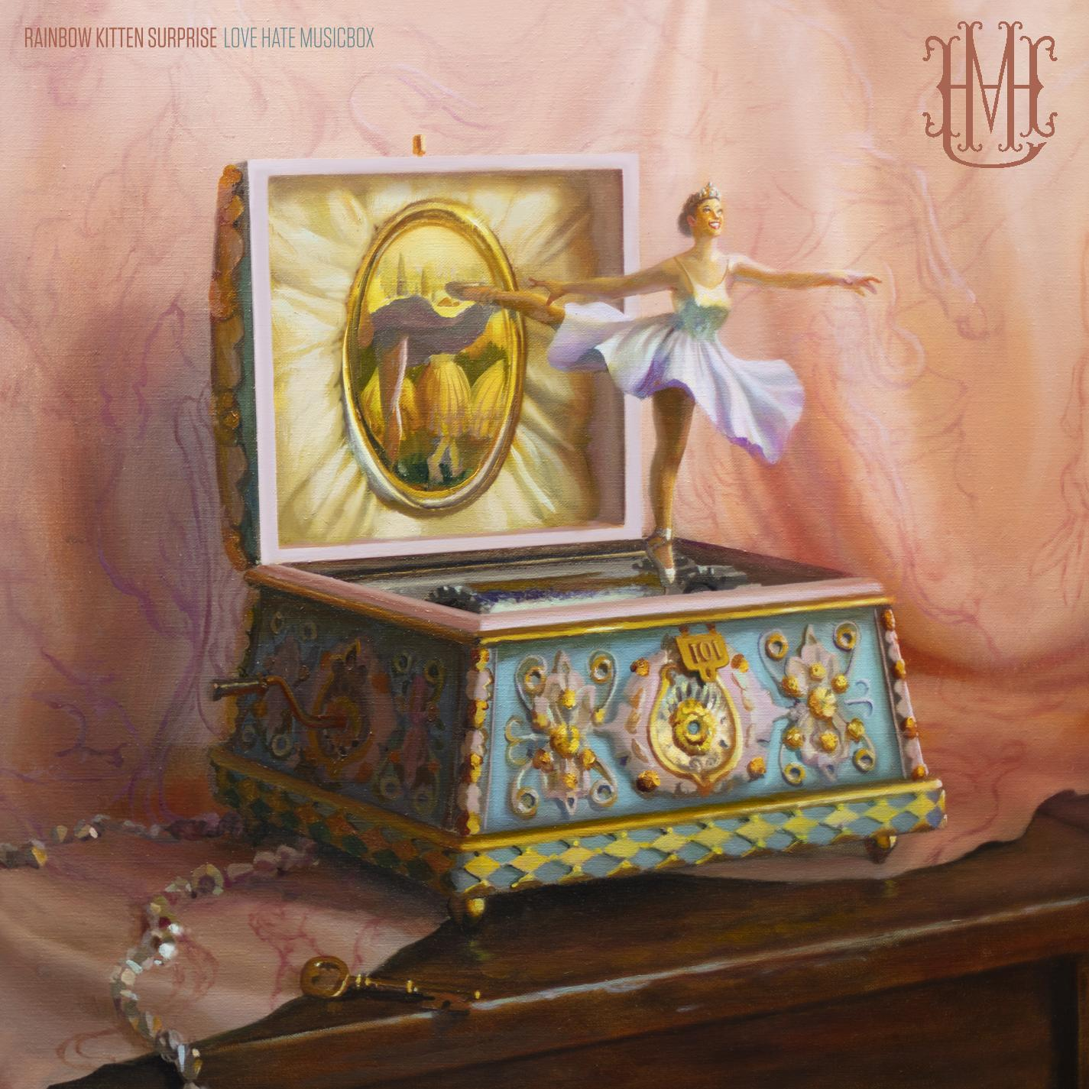

###

ABOUT RAINBOW KITTEN SURPRISE:
As if channeling another dimension where genres simply don’t exist, Rainbow Kitten Surprise finds harmony in unpredictability – weaving together lyrical poetry, hummable melodies, and a rush of instrumental eccentricities. Now boasting over 2 billion global streams across platforms, the band first began building their devoted fanbase with independent albums SEVEN + MARY(2013) and RKS (2015). The band’s breakout full-length debut for Elektra, HOW TO: FRIEND, LOVE, FREEFALL, arrived in April 2018. Produced by GRAMMY® Award-winner Jay Joyce (Cage The Elephant, Lainey Wilson), the album featured RIAA-certified Platinum single “It’s Called: Freefall,” earned widespread praise from Billboard, TIME, Vice, and NPR who described their sound as “…a mix of jam and indie and whatever else you can throw into the soup…very earnest, beautiful, political, loving rock n’ roll,” and saw the band make several national television appearances, including performances on “CBS Saturday Morning,” “The Late Show with Stephen Colbert,” and PBS’s “Austin City Limits.” After gracing the bills of Bonnaroo, Lollapalooza, and Osheaga, to name a few, RKS moved 80,000 tickets of their own on the sold-out 2018/2019 Friend, Love, Freefall Tour. That tour was earmarked by a sold-out debut at Red Rocks Amphitheatre and three consecutive gigs in Athens, GA (the latter of which were chronicled on their first official live album, LIVE FROM ATHENS GEORGIA, released in 2021).

The band released a two-track single Mary (B-Sides) in May 2019 – consisting of “Heart” and “No Vacancy.” The following year brought the release of standalone single “Our Song” – already a fan favorite in their live rotation prior to release – as well as a livestream concert in July, held for thousands of fans on what would’ve been the date of another sold-out Red Rocks performance (cancelled due to the COVID-19 pandemic). In March 2022, the band released the emotionally charged track “Work Out,” marking their first new music in nearly two years.

2022 also saw the band set out on their first full headline trek in nearly 3 years, a run that included their long-awaited, sold-out, two-night return to Red Rocks. And in 2022 alone, with the help of partners PLUS1 and Propeller, Rainbow Kitten Surprise raised over $170k for food banks in local tour markets, LGBTQ+ causes, and mental health initiatives.

Rainbow Kitten Surprise is: Ela Melo (she/her; lead vocals), Darrick “Bozzy” Keller (he/him; guitar, vocals), Ethan Goodpaster (he/him; lead guitar, vocals), Jess Haney (he/him; drums)

For more ticket information and tour updates, please visit [www.rksband.com/tour].

###

For more information, please visit:
RAINBOWKITTENSURPRISE.COM
FACEBOOK * TWITTER * INSTAGRAM * YOUTUBE * SPOTIFY

PRESS CONTACTS:
Glenn Fukushima | GlennFukushima@elektra.com
Libby Kober | Libby.Kober@atlanticrecords.com

