January 19, 2024

Today, Brittney Spencer shares her highly anticipated debut album, My Stupid Life via Elektra. Spencer has already been crowned by CBS Mornings as “Nashville’s new star,” and this 13-track album is a culmination of her experience over the course of her time trying to “make it” in Music City, discovering herself in the process.

LISTEN TO 'MY STUPID LIFE' HERE

Recorded at Sound Emporium Studios and Blackbird Studio in Nashville, the album is produced by GRAMMY award-winning Daniel Tashian (Kacey Musgraves, Little Big Town, Brett Eldredge), with select songs produced by Marcus “MarcLo” Lomax and Romil Hemnan. The project also features award-winning collaborators including Grace Potter, Maren Morris, Abbey Cone and Sarah Buxton, plus guitar contributions by Jason Isbell.

Here is what critics are saying:

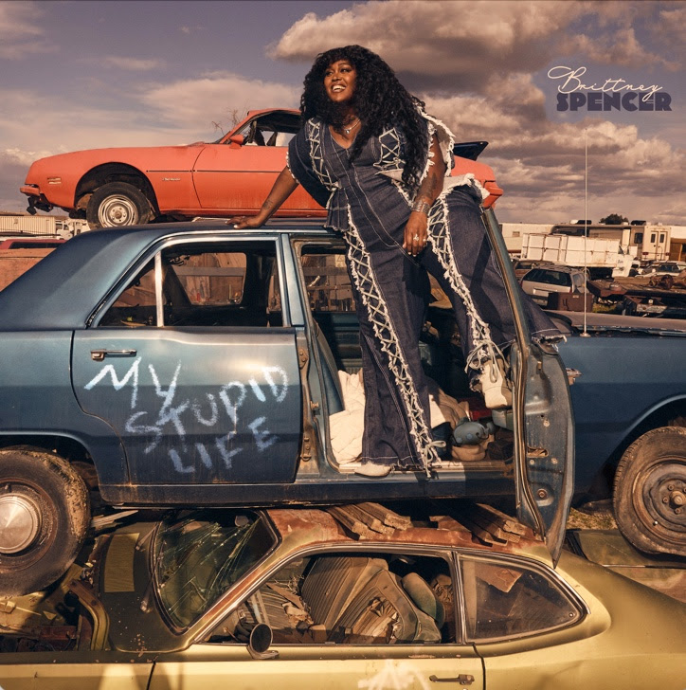
"one of the most convincing country statements in a while"
- Rolling Stone

"a remarkable inaugural album"
- Wall Street Journal

"a confident and
powerful new voice and persona"
- Variety

"Spencer defies categorization"
- Associated Press / AP

"Brittney Spencer is a star"
- Austin City Limits

"a periphery-expanding mix of pop, country, R&B and rock"
- Billboard

​​"refreshingly autobiographical"
- The Tennessean

"her identity propels her forward as an up-and-coming artist"
- Consequence

"a watershed roots-pop debut filled with girl power and confessional grace"
- Nashville Lifestyles

"open and unapologetic"
- TIDAL

Watch/Listen to Spencer's recent appearances:

Good Morning America

NPR All Things Considered (HOLD)

TODAY

Upcoming Appearances:

Mon., Jan. 22 - CBS Mornings with Anthony Mason

Sat., Jan. 27 - CBS Saturday Sessions

Sat., Feb. 3 - Austin City Limits TV

Recent Accolades:

GRAMMY's 2024 Artists to Watch

Rolling Stone Future 25 of Music

Variety 2024 Most Anticipated Albums

Consequence 15 Rising Artists to Watch in 2024

TIDAL 2024 Artist to Watch
﻿
Amazon’s Breakthrough Artists to Watch Country Class

My Stupid Life Tracklist:
1. “New To This Town” (Brittney Spencer)+
2. “I Got Time” (Spencer, Jessica Cayne, Nate Campany, Emily Reid)
3. “Night In (Phone Call)”
4. “Night In” (Spencer, Cayne, Summer Overstreet)
5. “Bigger Than The Song” (Spencer, Jennifer Anne Wayne, Tofer Brown)*
6. “My First Rodeo” (Spencer, Cayne, Sean Douglas, Zach Skelton)
7. “The Last Time” (Spencer, Sean McConnell, Sarah Buxton)
8. “Deeper” (Spencer, Tayla Parx, Gustav Landell)
9. “First Car Feeling” (Spencer, Cayne, Kat Higgins)
10. “Desperate” (Spencer, Emily Falvey, Mikey Reeves)
11. “If You Say So” (Spencer)
12. “My Stupid Life” (Spencer, James Brock Human, McConnell)
13. “Reaching Out” (Spencer, Joe Kirkland)

My Stupid Life Credits:
Produced by: Daniel Tashian
Select songs produced by: Marcus “MarcLo” Lomax*, Romil Hemnani+
Mixed by: Dave Clauss, Manny Marroquin, Jonathan Low, Jason Agel
Mastered by: Greg Calbi
Engineered by: Gena Johnson, Konrad Snyder, Marcus “MarcLo” Lomax, Garry Purohit
Background vocals: Grace Potter (“Reaching Out”), Maren Morris (“Night In”), Abbey Cone (“The Last Time,” “Desperate”) & Sarah Buxton (“I Got Time,” “My First Rodeo,” “The Last Time,” “Deeper,” “Desperate,” “If You Say So”)
Featured instrumentalist: Jason Isbell (“First Car Feeling,” “Reaching Out”)

﻿Brittney Spencer On Tour:
Fri., Jan. 19 | State Theatre | Portland, ME
Sun., Jan. 20 | MGM Music Hall at Fenway | Boston, MA
Mon., Jan. 21 | Infinity Music Hall | Hartford, CT
Wed., Jan. 24 | The Paramount | Huntington, NY
Thurs., Jan. 25 | Count Basie Center for the Arts | Red Bank, NJ
Fri., Jan. 26 | The Fillmore Philadelphia | Philadelphia, PA
Sat., Jan. 27 | The Anthem | Washington, DC
Mon., Jan. 29 | Lincoln Theatre | Raleigh, NC
Tues., Jan. 30 | The Senate | Columbia, SC
Thurs., Feb. 1 | Florida Theatre | Jacksonville, FL
Fri., Feb. 2 | House of Blues Orlando | Lake Buena Vista, FL
Sat., Feb. 3 | Culture Room | Ft. Lauderdale, FL
Sun., Feb. 4 | The Moon | Tallahassee, FL
Wed., Feb. 7 | Hargay Capitol Theatre | Macon, GA
Fri., Feb. 9 | The Ryman Auditorium | Nashville, TN
Sat., Feb. 10 | Iron City Birmingham | Birmingham, AL
Wed., Feb. 14 | Chelsea’s Live | Baton Rouge, LA
Fri., Feb. 16 | ACL Live at the Moody Theater | Austin, TX
Sat., Feb. 17 | Granada Theater | Dallas, TX
Fri., Mar. 1 | The Showbox | Seattle, WA
Sat., Mar. 2 | Mount Baker Theatre | Bellingham, WA
Sun., Mar. 3 | Roseland Theater | Portland, OR
Mon., Mar. 4 | Midtown Ballroom | Bend, OR
Wed., Mar. 6 | The Fillmore | San Francisco, CA
Fri., Mar. 8 | The Crystal Bay Club Casino Crown Room | Crystal Bay, NV
Sat., Mar. 9 | The Crystal Bay Club Casino Crown Room | Crystal Bay, NV
Sat., Mar. 16 | The Sound at Del Mar | Del Mar, CA
Fri., Apr. 26-Sun., Apr. 28 | Stagecoach Festival | Indio, CA
Sat., June 1 | Railbird Music Festival | Lexington, KY
*Note: All non-festival dates are support for the “Grace Potter: Mother Road Tour”

Spencer is represented by Elektra, Activist Artists Management, UTA, and Shore Fire Media.

Follow Brittney Spencer:
Website: brittneyspencer.com
Instagram: instagram.com/brittneyspencer
TikTok: tiktok.com/@brittney.spencer
Facebook: facebook.com/brittneyspencermusic
YouTube: youtube.com/c/BrittneySpencer

Digital Press Page:
shorefire.com/roster/brittney-spencer

Management:
Matt Maher | Activist Artists Management | maher@activist.co
Caitlin Stone Jasper | Activist Artists Management | caitlin@activist.co

Press Contacts:
Jaclyn D. Carter | Shore Fire Media | jcarter@shorefire.com
Andrea Evenson | Shore Fire Media | aevenson@shorefire.com
Maria Eilert | Shore Fire Media | meilert@shorefire.com
Glenn Fukushima | Elektra | GlennFukushima@elektra.com

Booking Agent:
Jeffrey Hasson | UTA | jeffrey.hasson@unitedtalent.com

Brands:
Emily Wright | UTA | emily.wright@unitedtalent.com

